Class 12 chapter 1

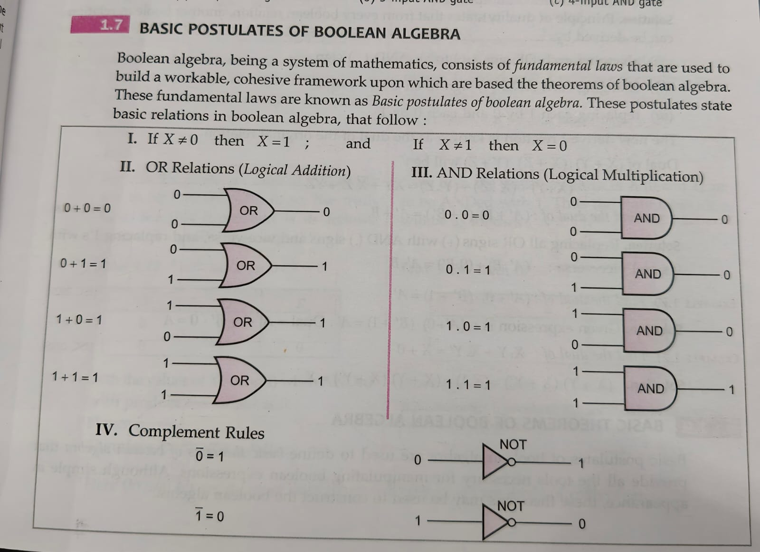**Boolean algebra**

**PRINCIPLE OF DUALITY**

This is a very important principle used in boolean algebra. This states that starting with a boolean relation, another boolean relation can be derived by

**1. Changing each OR sign (+) to an AND sign (.)**

**2. Changing each AND sign (.) to an OR sign (+)**

**3. Replacing each 0 by 1 and each 1 by 0.**

The derived relation using duality principle is called dual of original expression.

For instance, we take postulate II related to logical addition, which states

(a) 0+0=0 (b) 0+1=1 (c) 1+0=1 (d) 1+1=1

Now working according to above guidelines, + is changed to, and O's are replaced by 1's, these become

(1) 1.1=1 (ii) 1.0=0 (iii) 0,.1 = 0 (iv) 0.0=0

which are nothing but same as that of postulate III related to logical multiplication. So i, ii, iii, iv are the duals of a, b, c & d. We'll be applying this duality principle in the theorems of boolean algebra which is our next topic.

EXAMPLE 1.18 State the principle of duality in boolean algebra and give the dual of the boolean expression:

(X+Y).(X+Z).(Y+Z)

Solution. Principle of duality states that from every boolean relation, another boolean relation can be derived by 2008

(1) changing each OR sign (+) to an AND (.) sign

(ii) changing each AND (.) sign to an OR (+) sign

(iii) replacing each 1 by 0 and each 0 by 1.

The new derived relation is known as the dual of the original relation.

Dual of (X + Y).(X+Z). (Y + Z) will be: (X.Y)+( overline X . overline Z )+(Y.Z)=XY+ overline X overline Z + YZ

EXAMPLE 1.19 Find the dual of :(A^ prime +B). (1 + B') = A' + B

[ISC 2018]

Solution. Replacing all OR signs (+) with AND (,) signs and vice-versa, and replacing 1's with O's and vice-versa ( A' .B)+(0.B^ prime )=A^ prime .B.

EXAMPLE 1.20 Find the dual of: (A' + 0)(B' + 1) = A'

[ISC 2020]

Solution. Given expression is: (A' + 0)(B' + 1) = A' Dual A'-1+B-0=A

AMPLE 1.21 Find the dual of: C.Y+X. Y' = X + 0

[ISC 2019]

Solution. (X+Y).(X+Y^ prime )=(X.1)=(X+Y). (X + Y') = X

*****************************************************************************

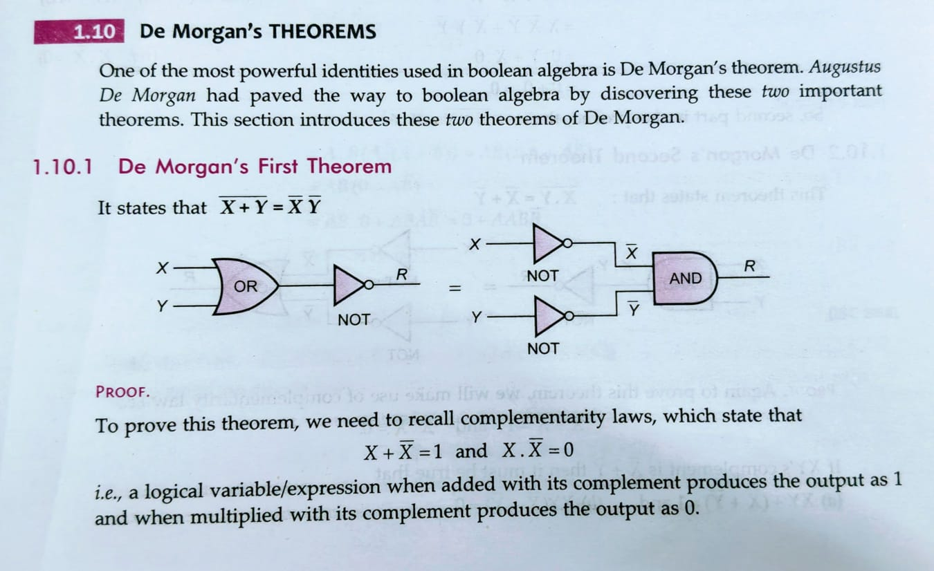

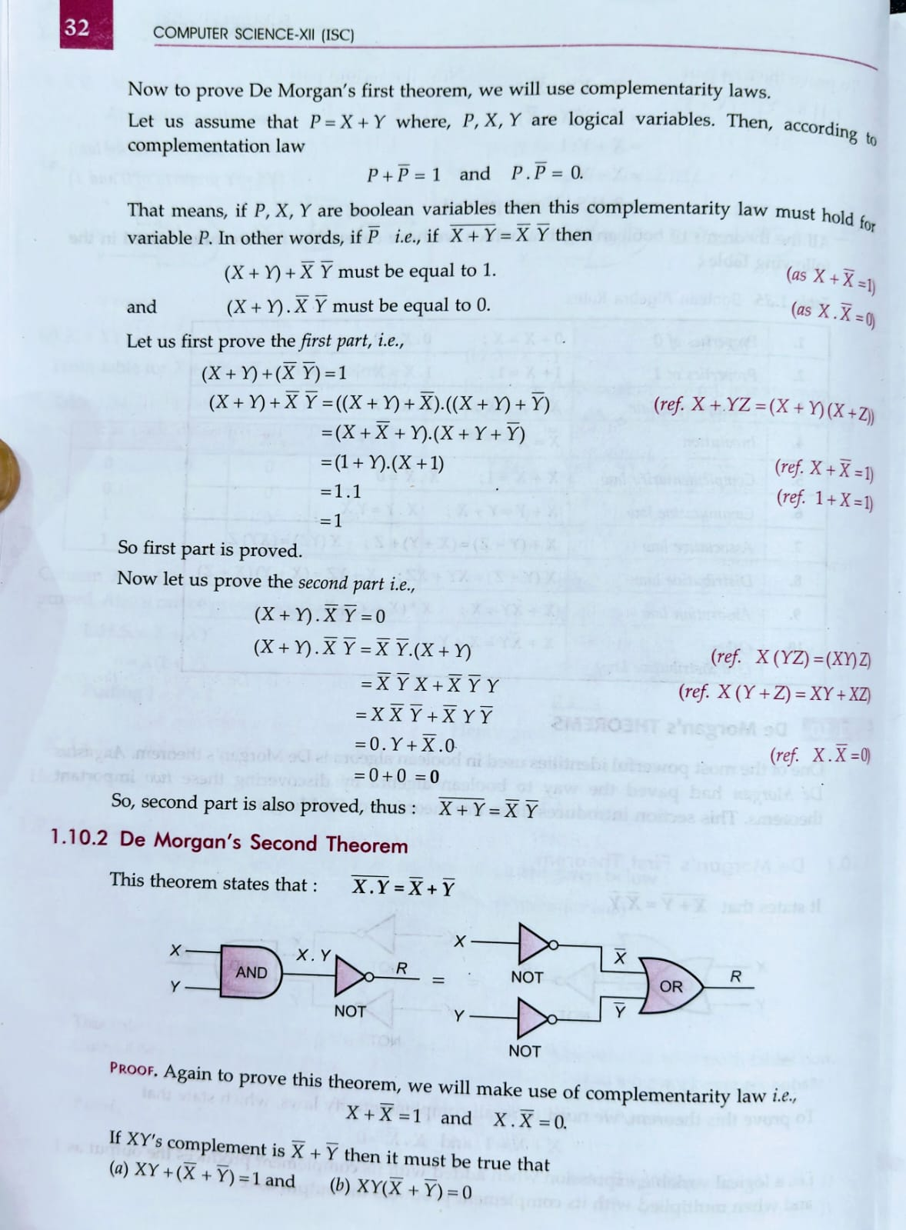



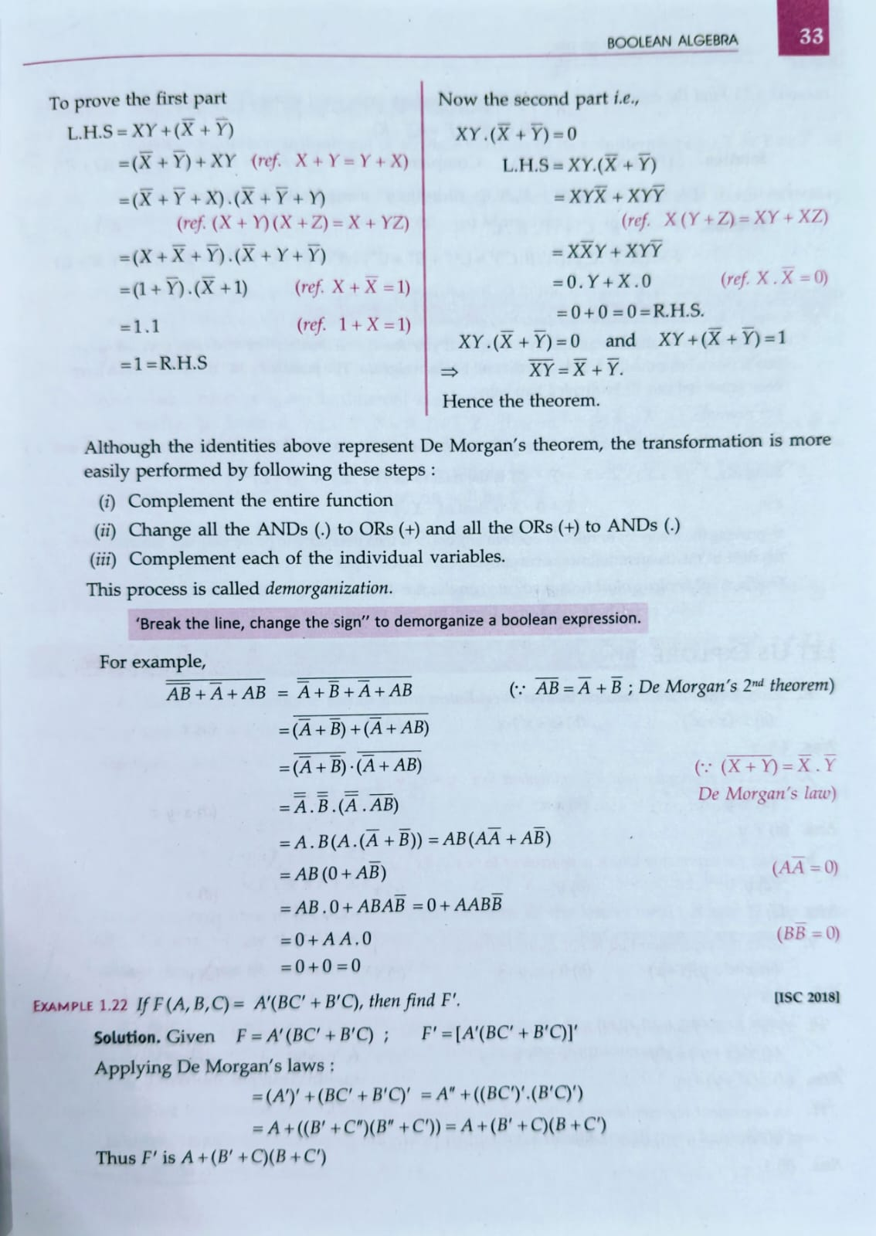

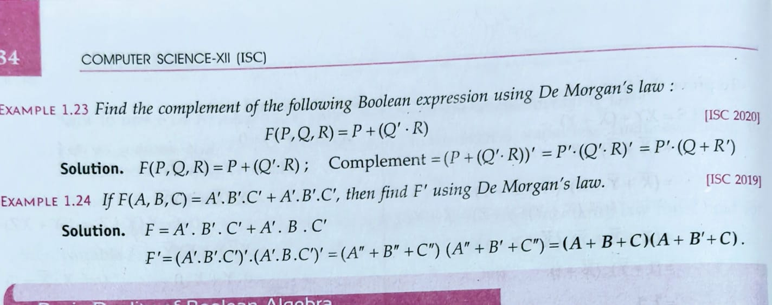

+

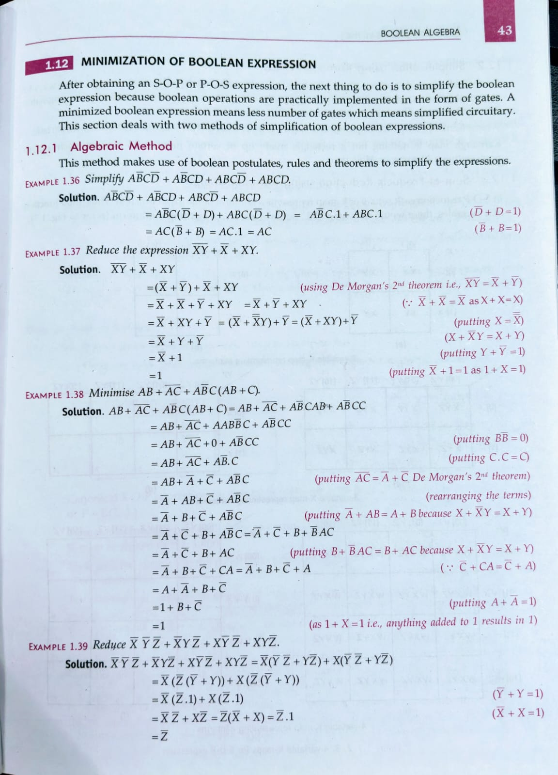

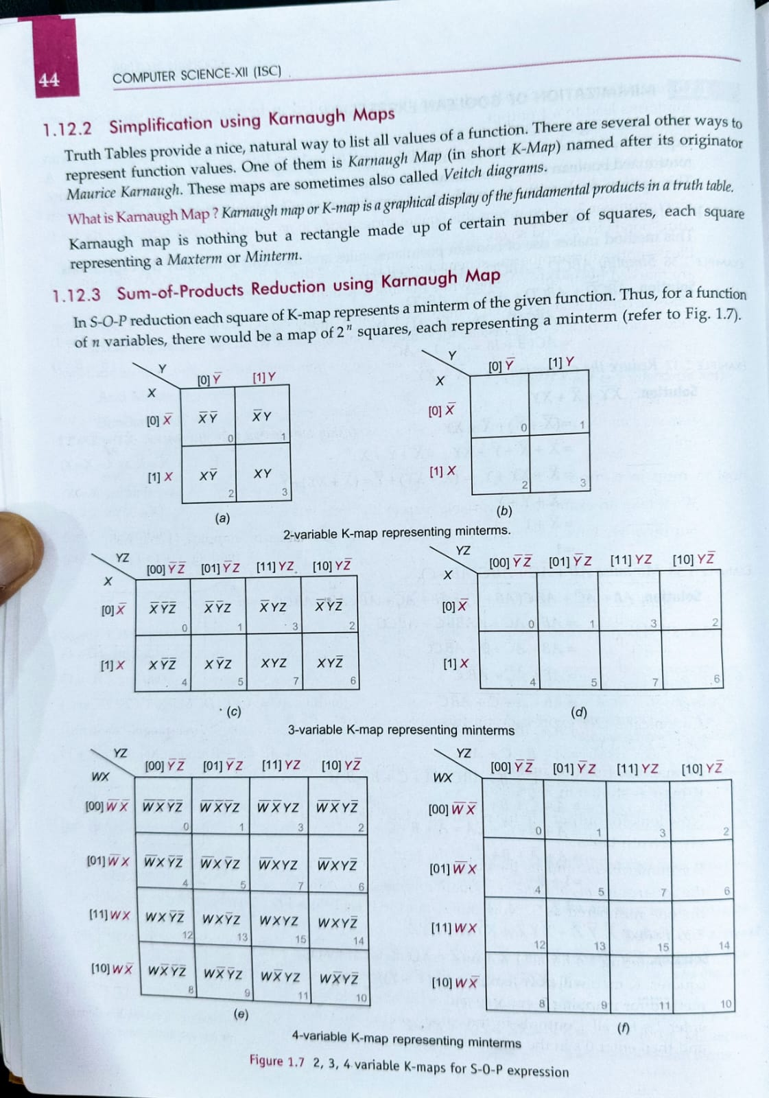

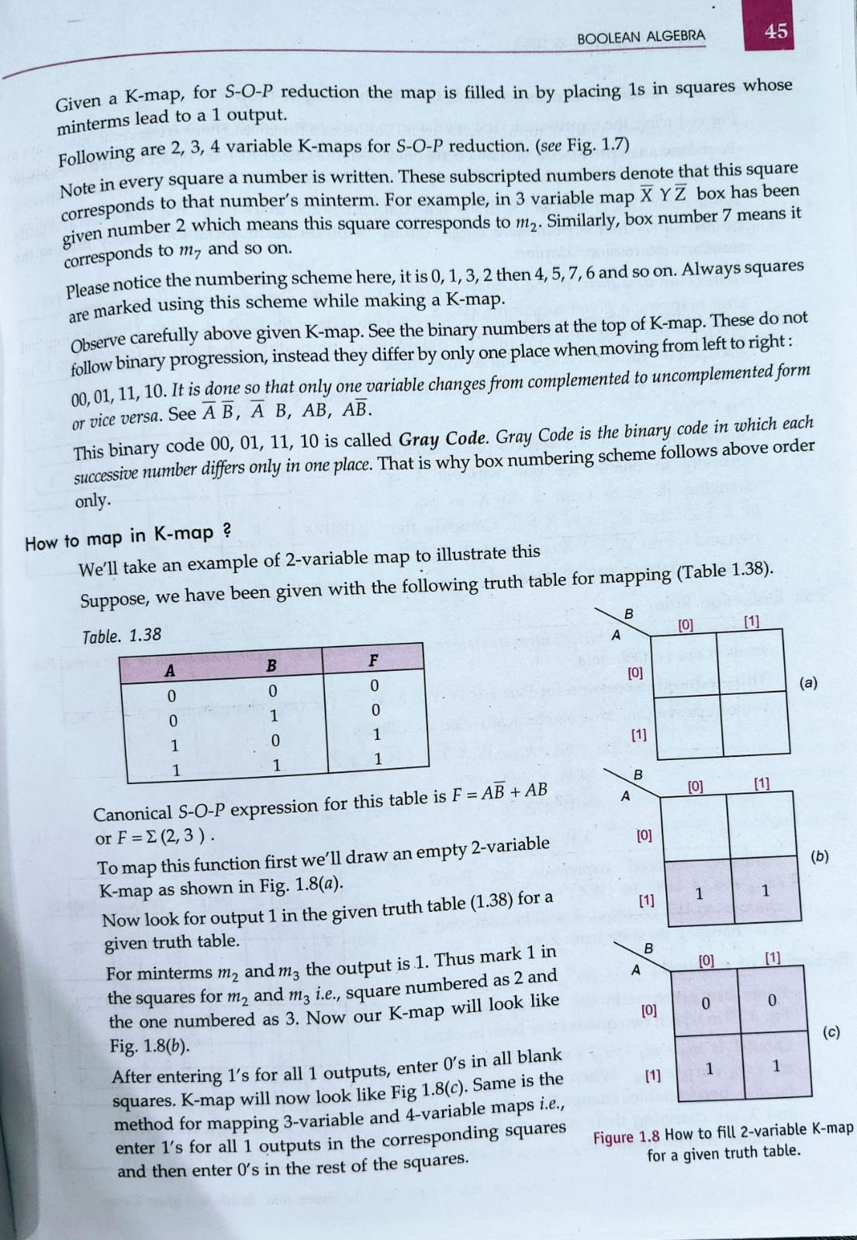

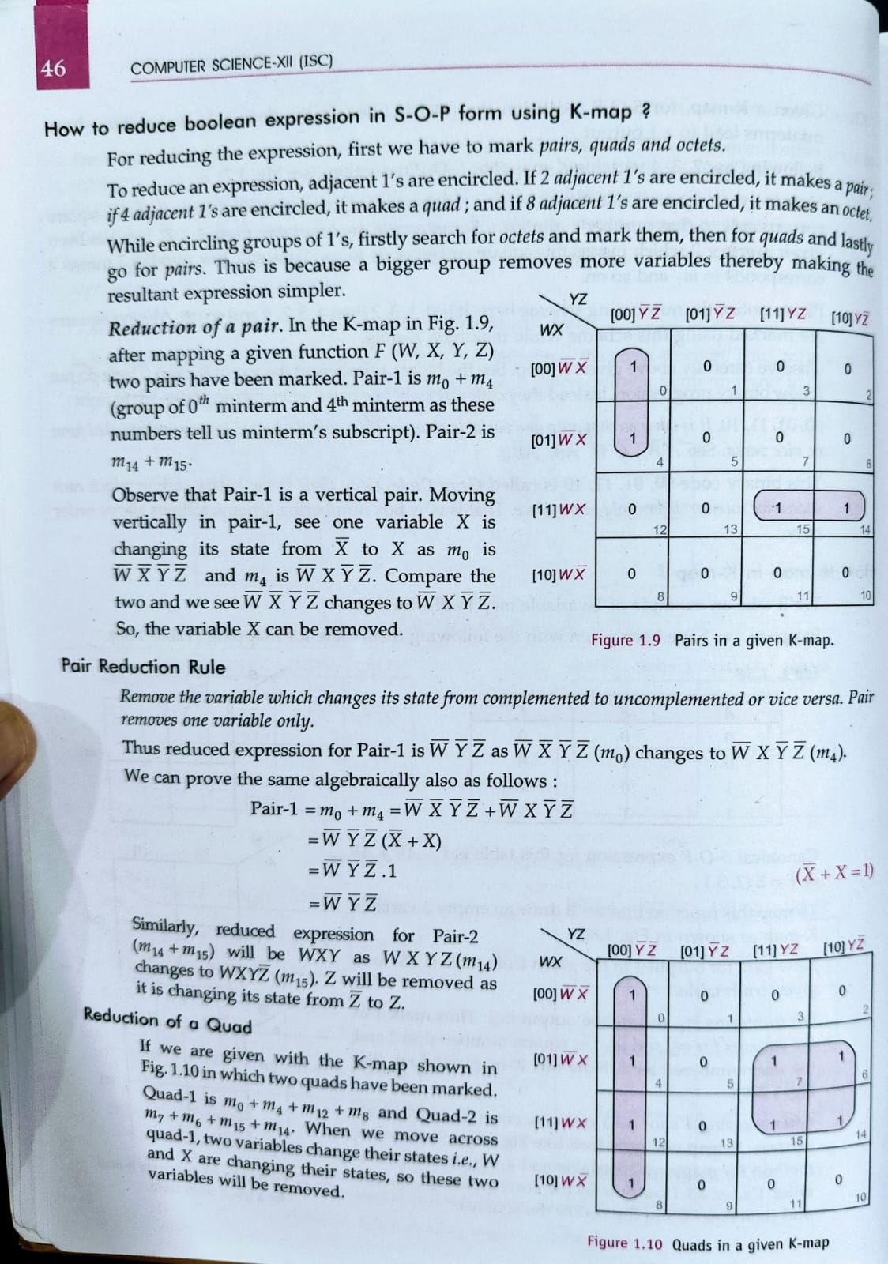

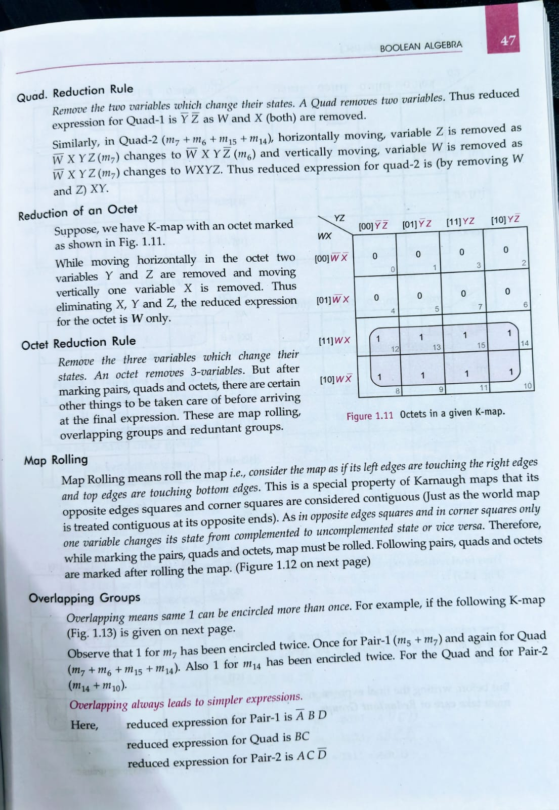

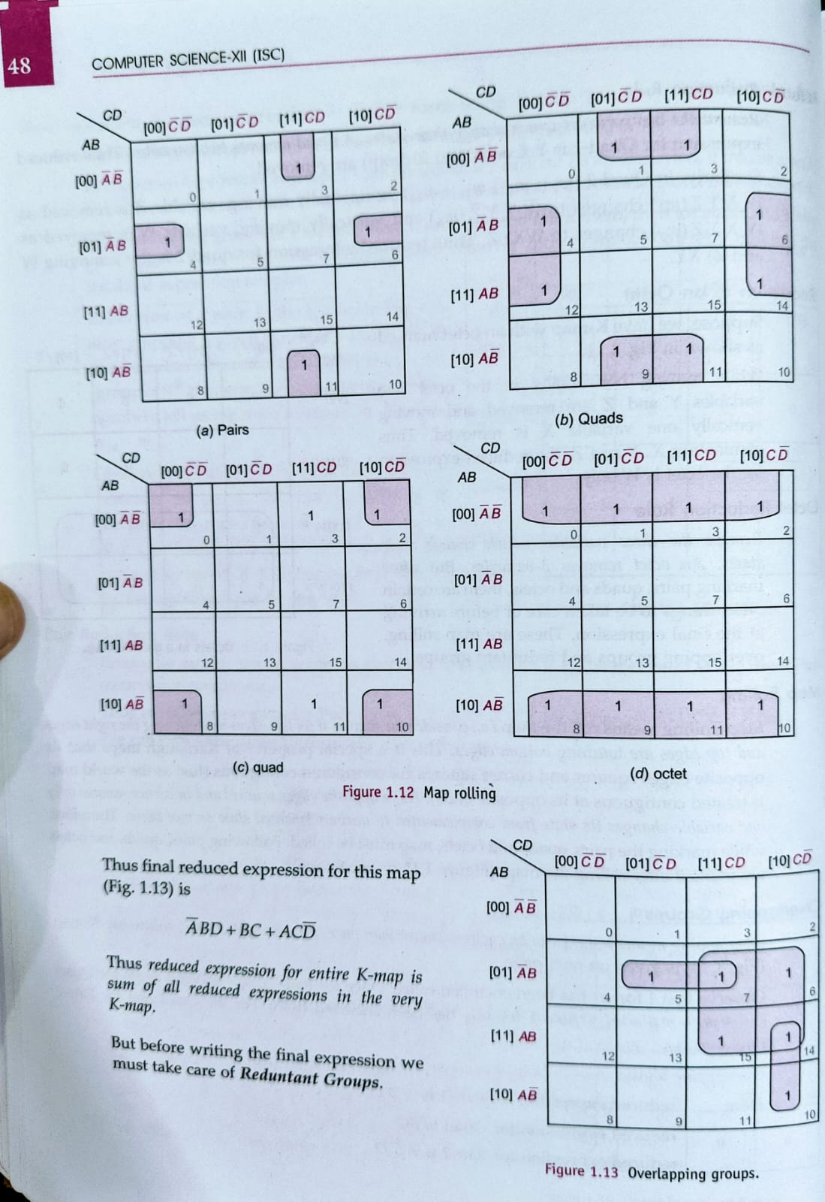

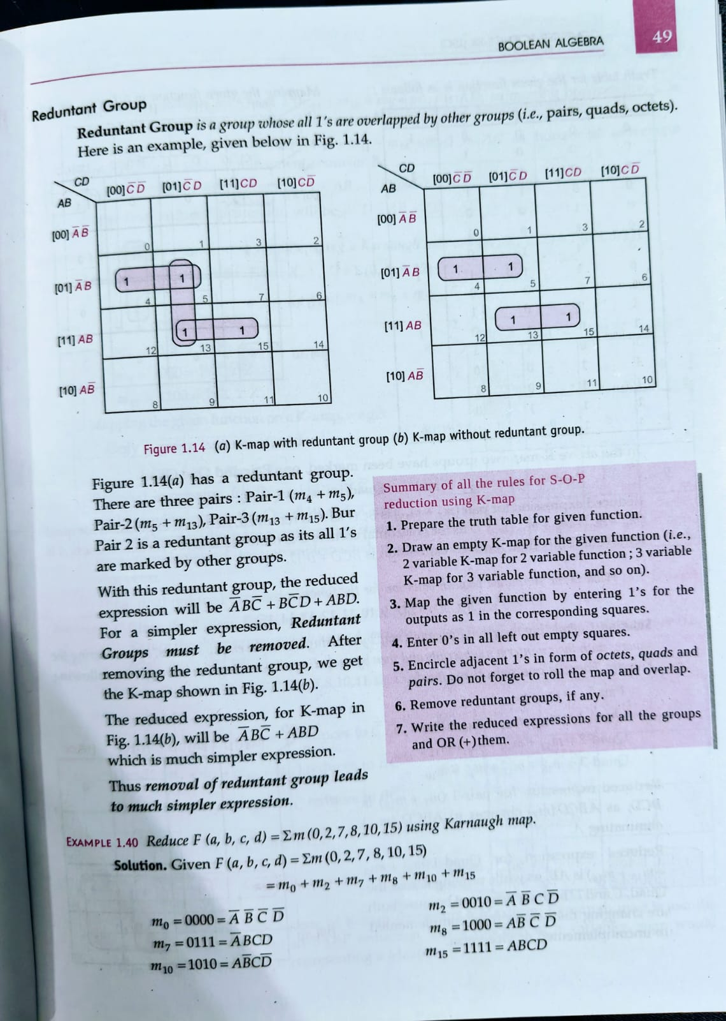

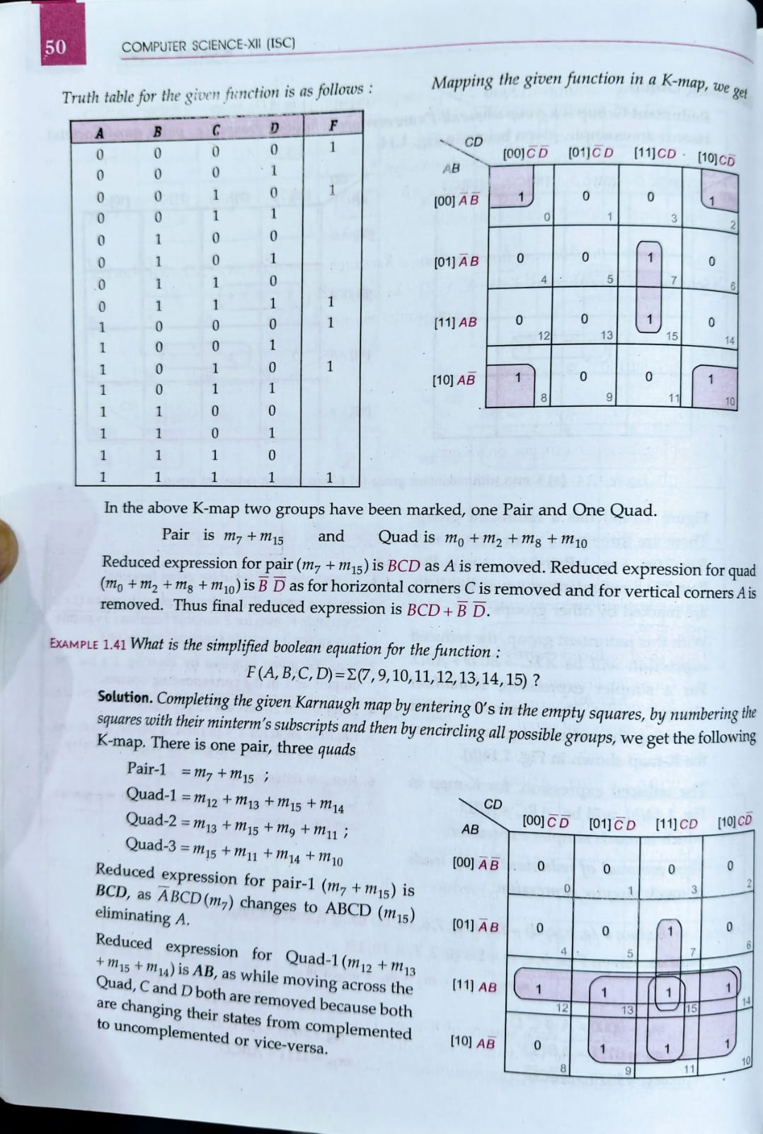

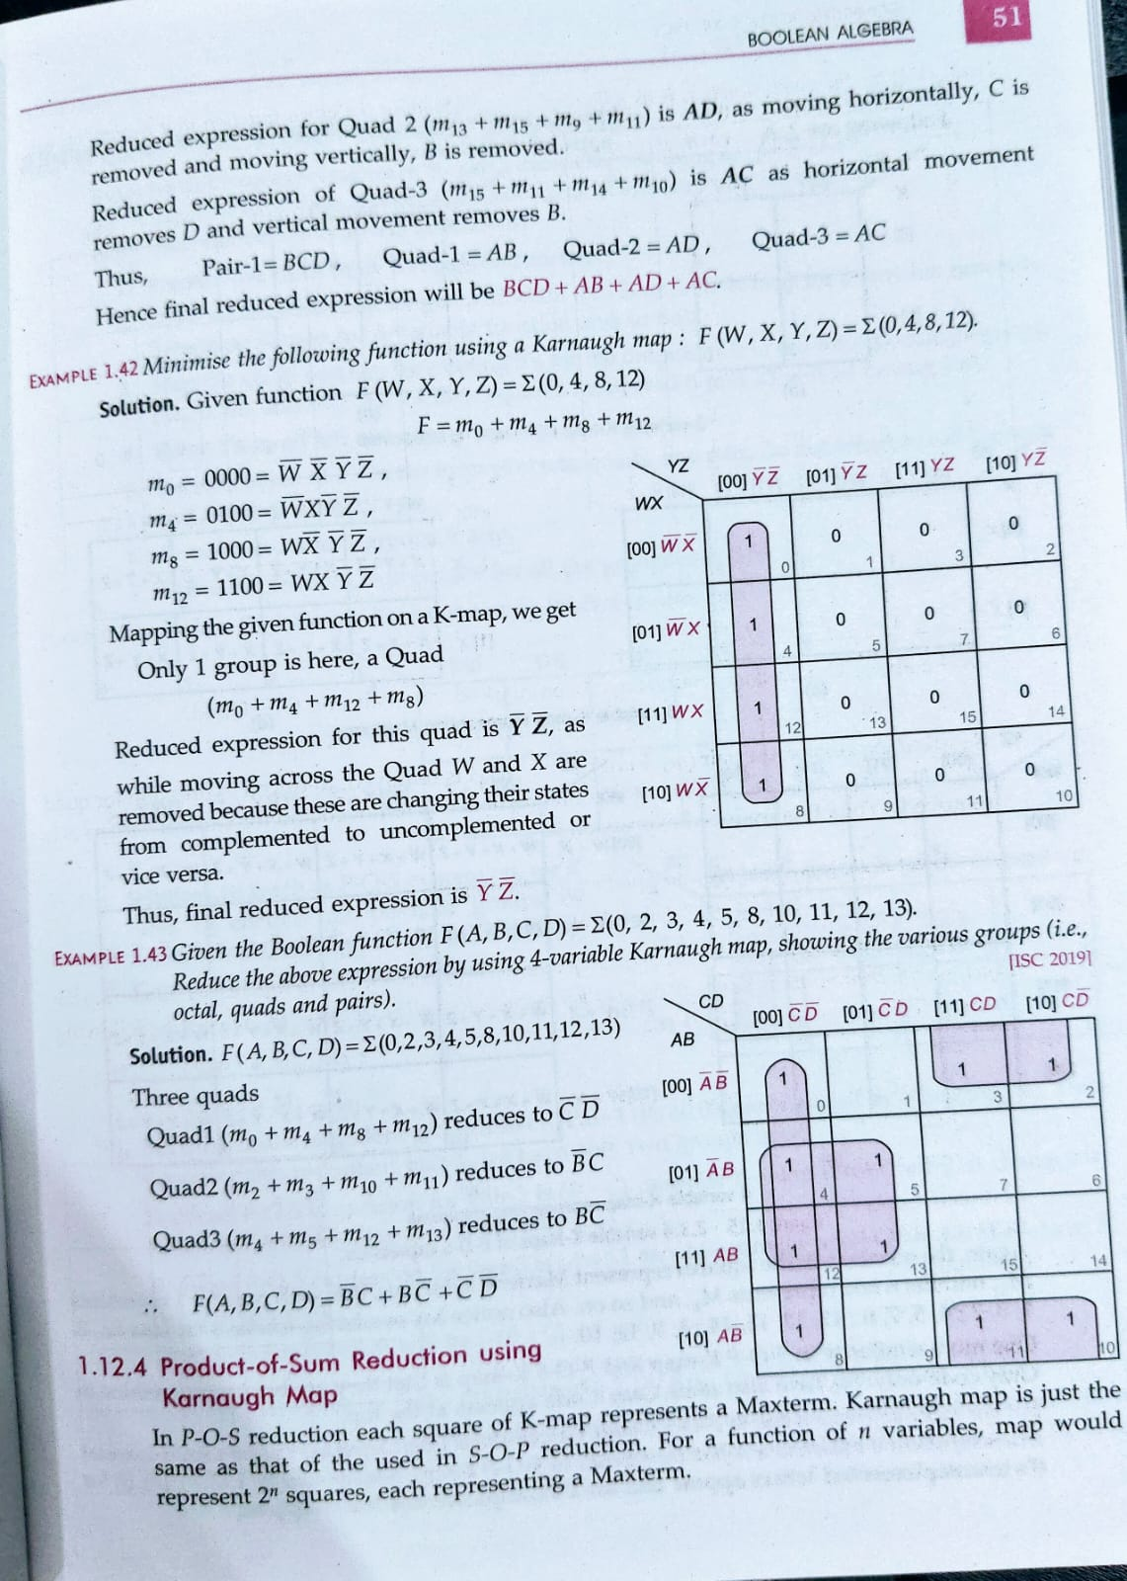



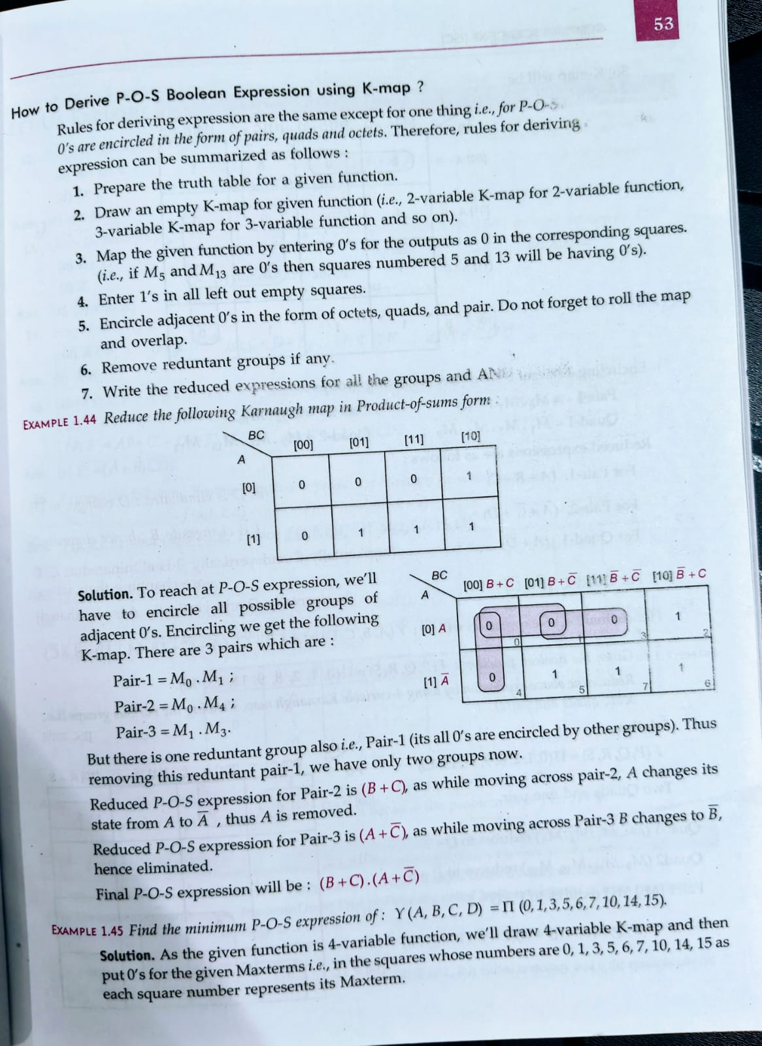

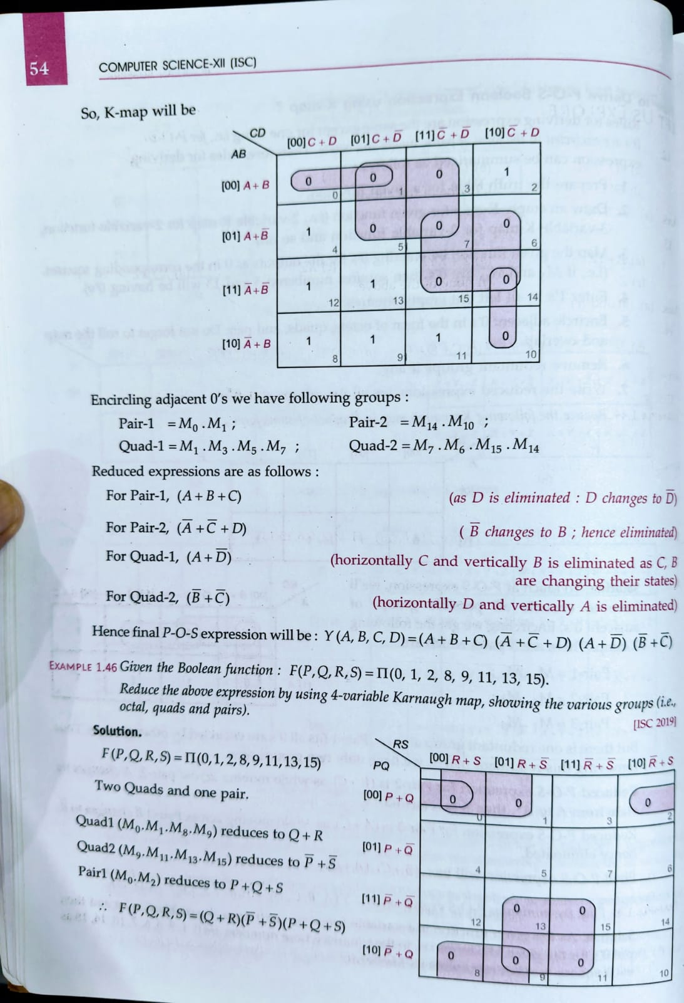

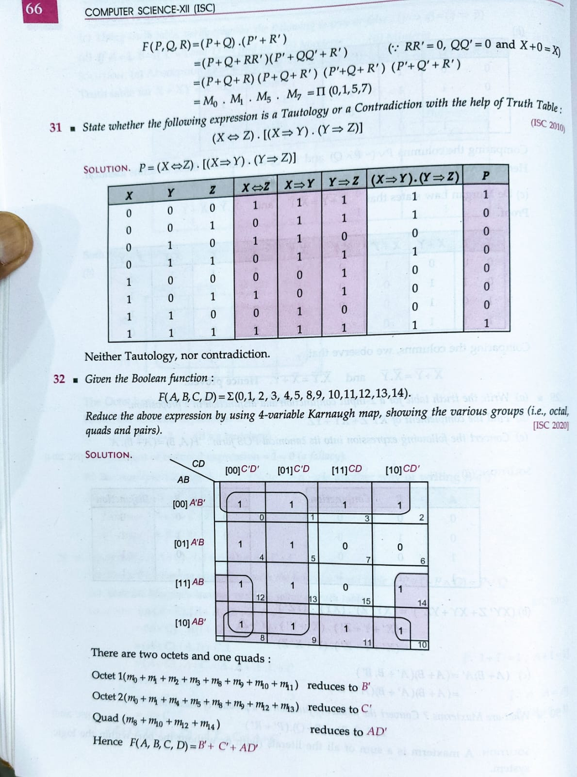

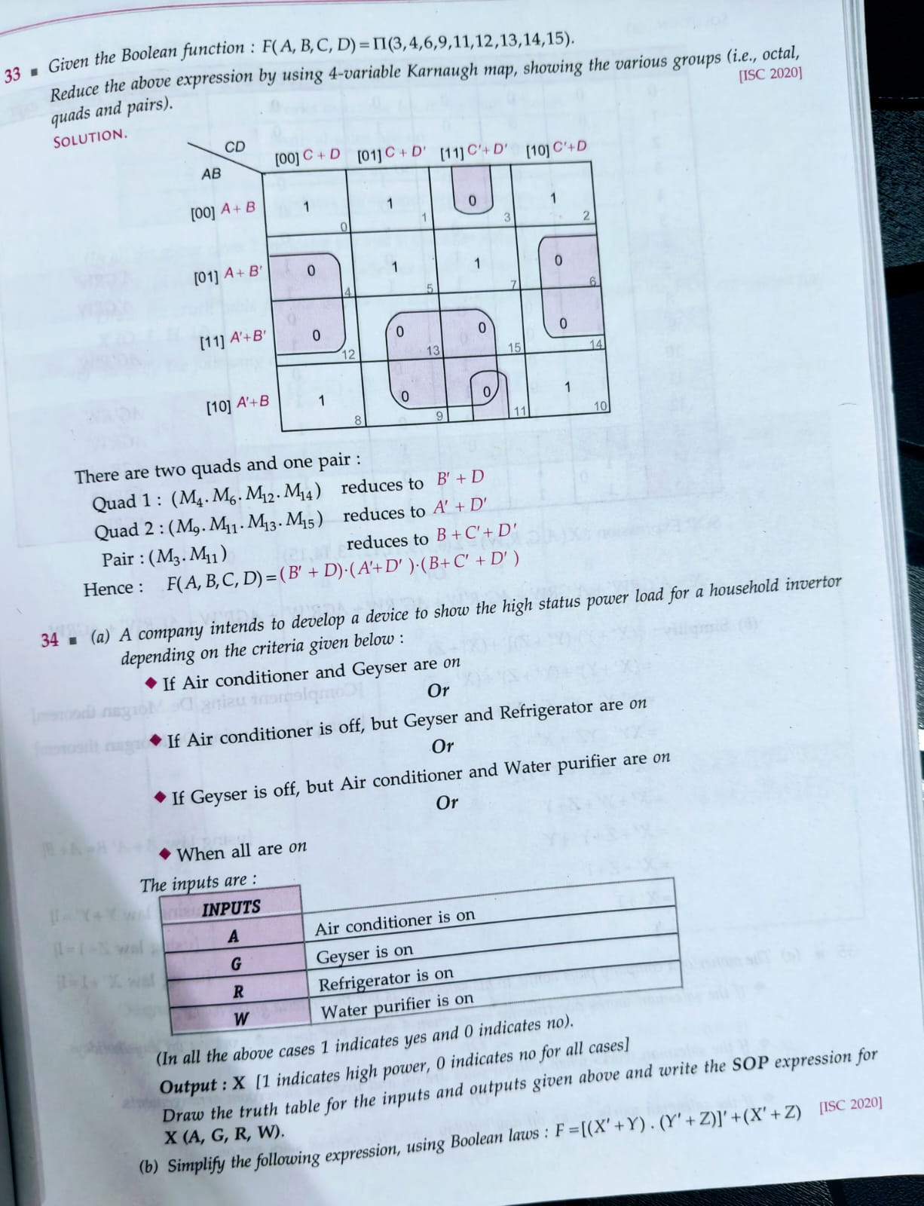

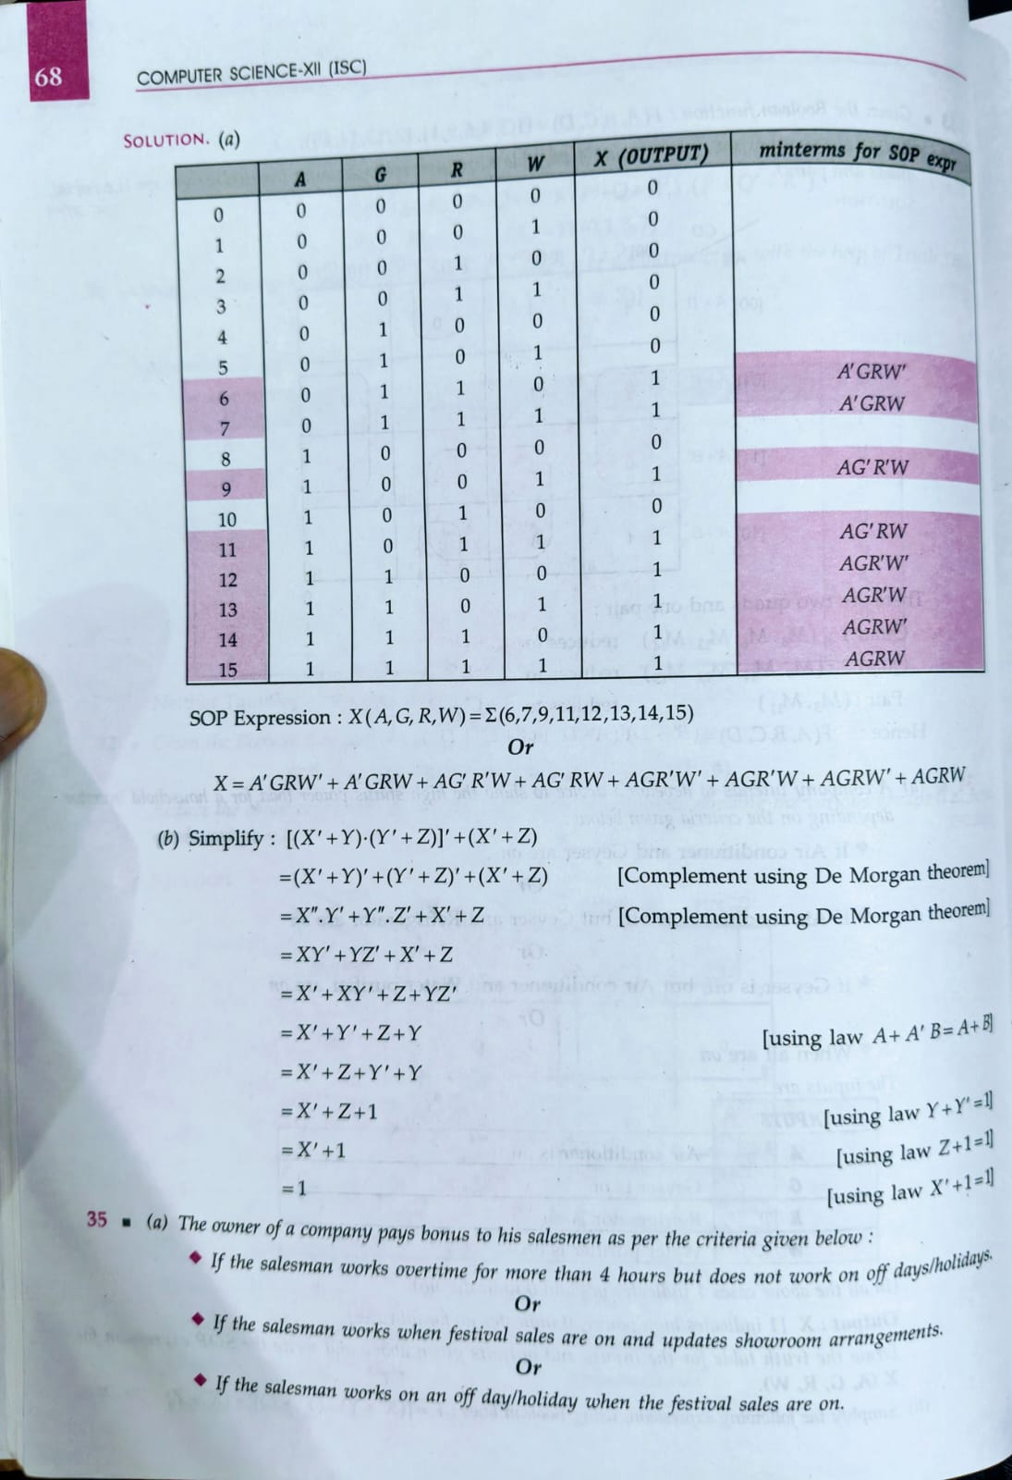

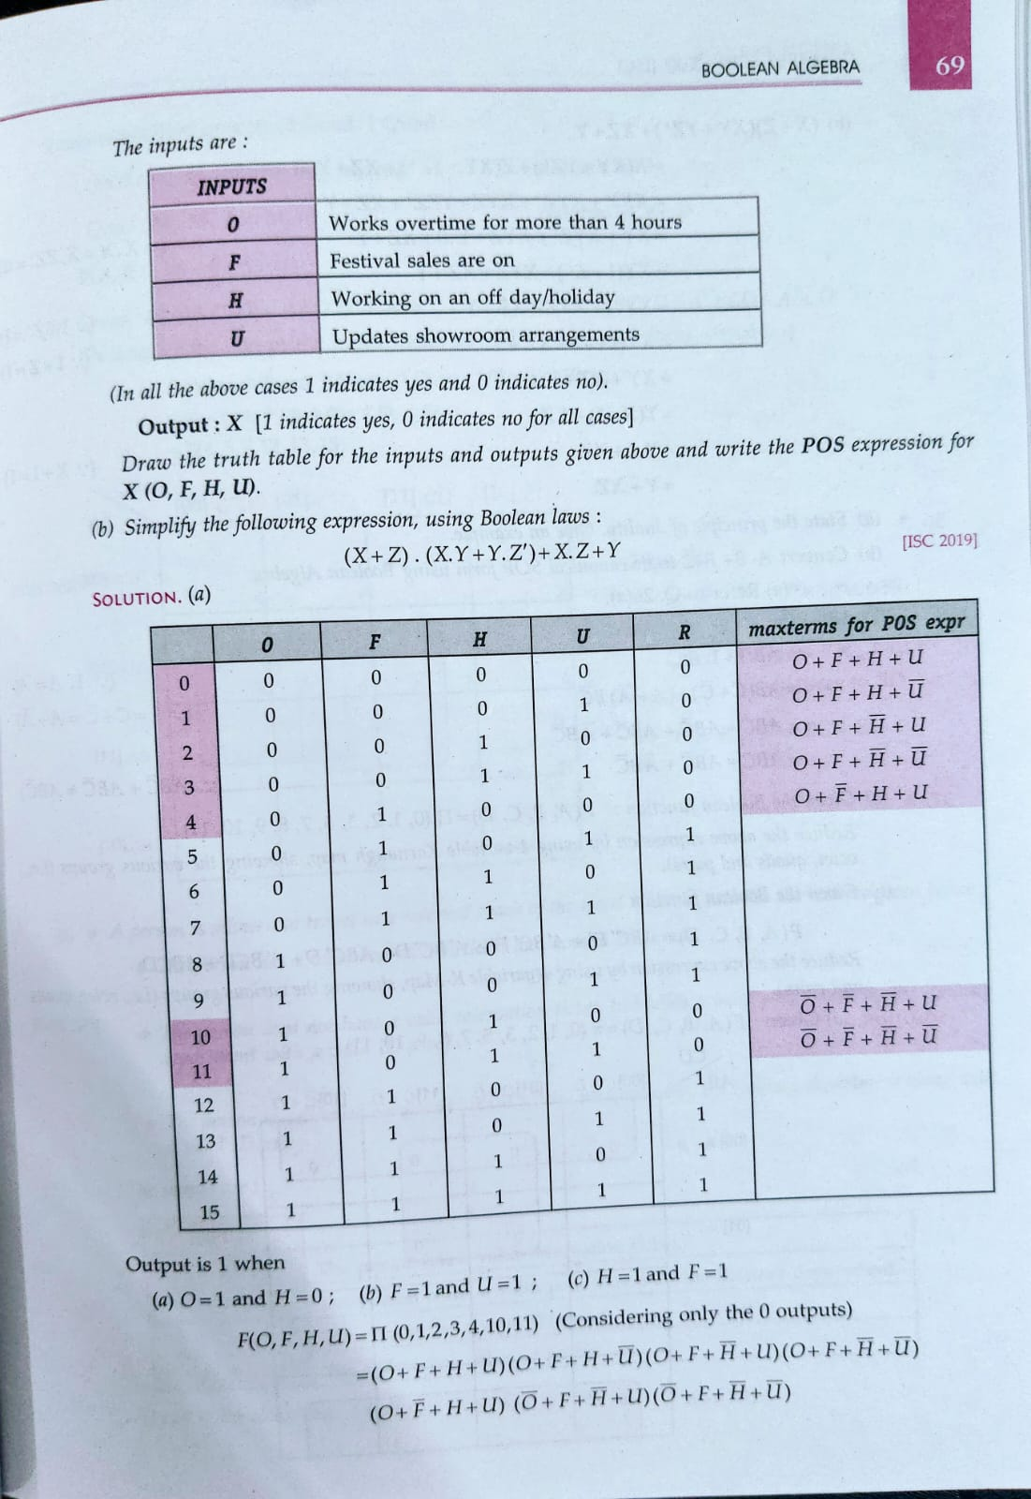

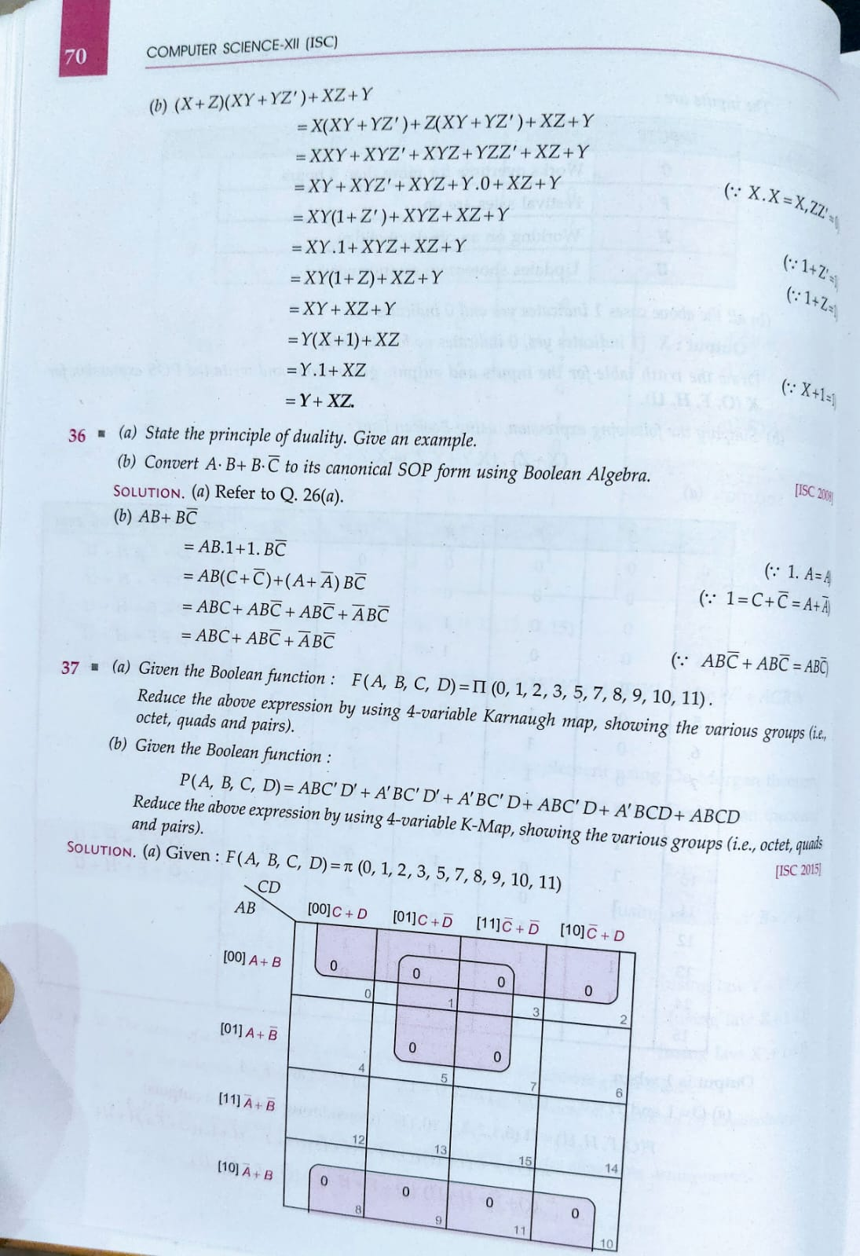

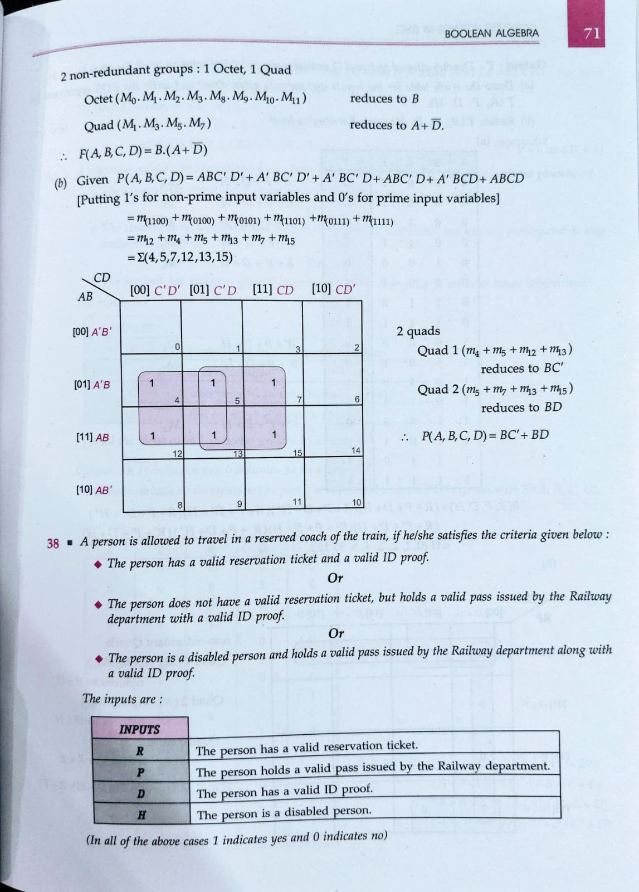

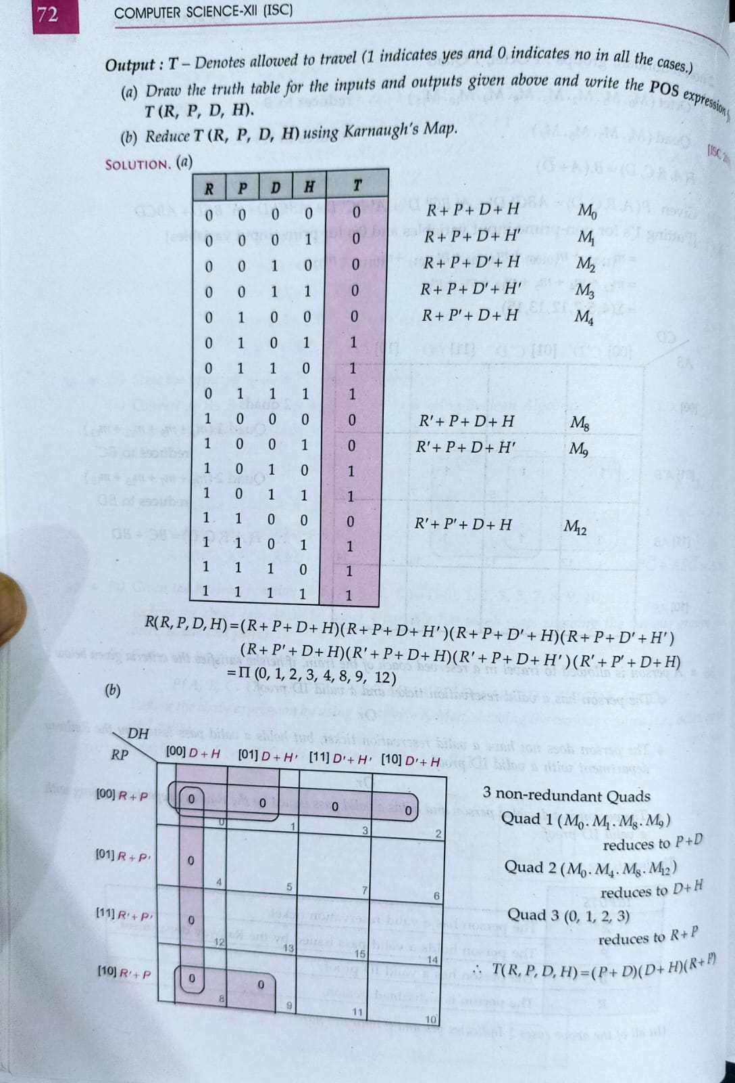

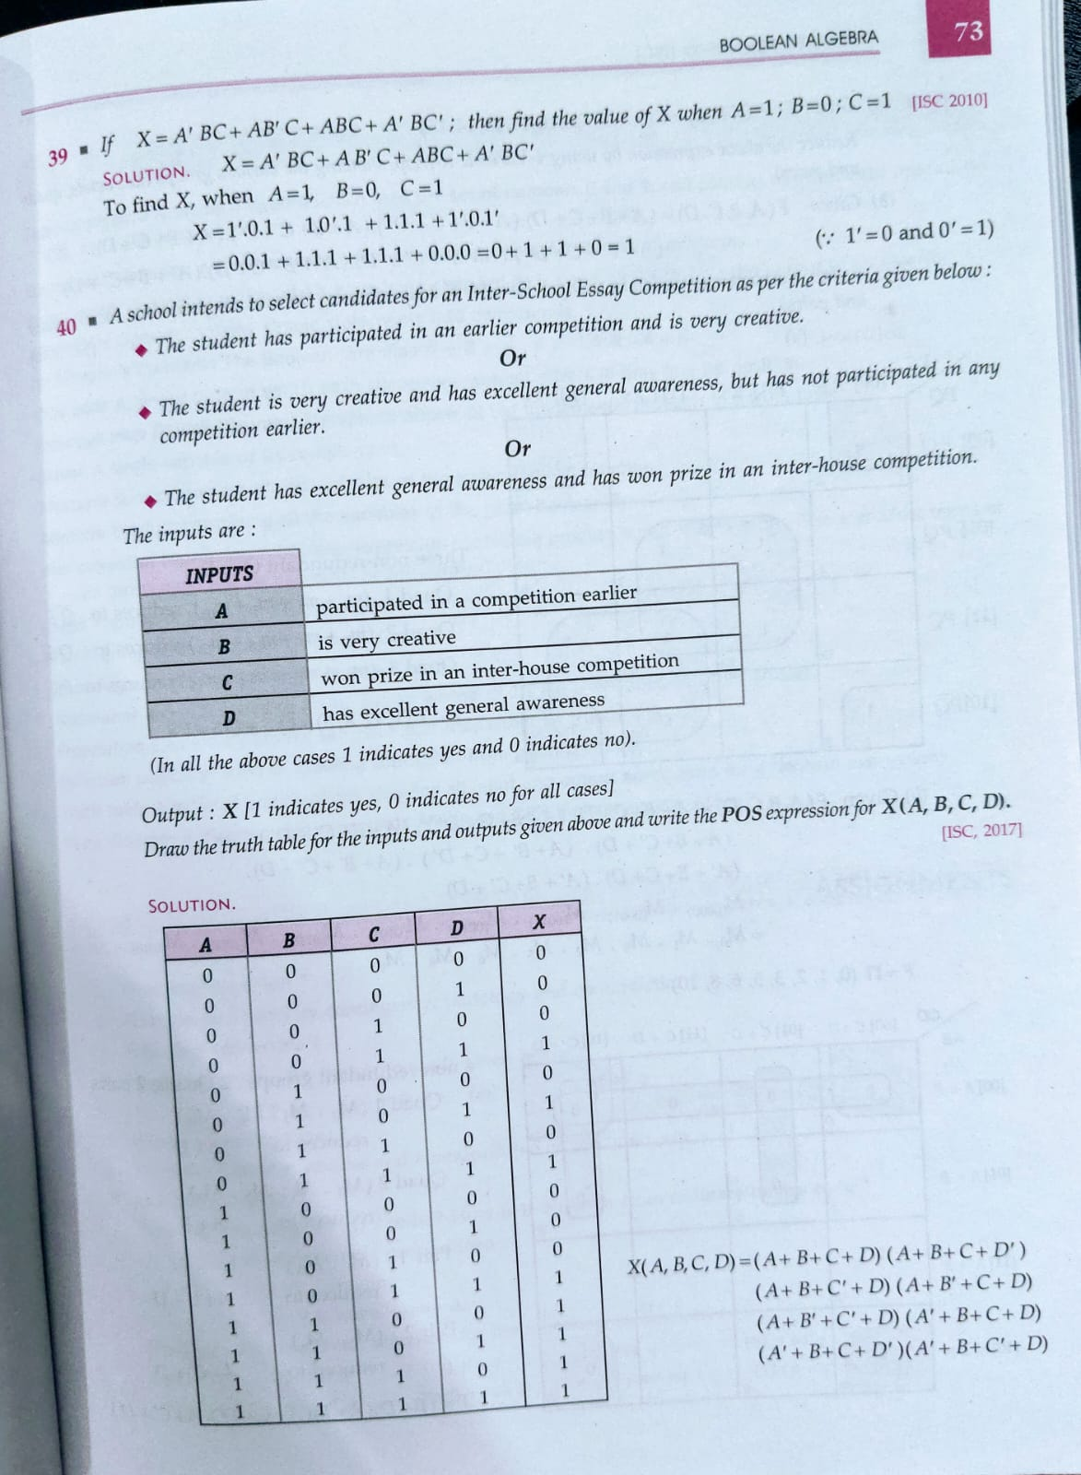

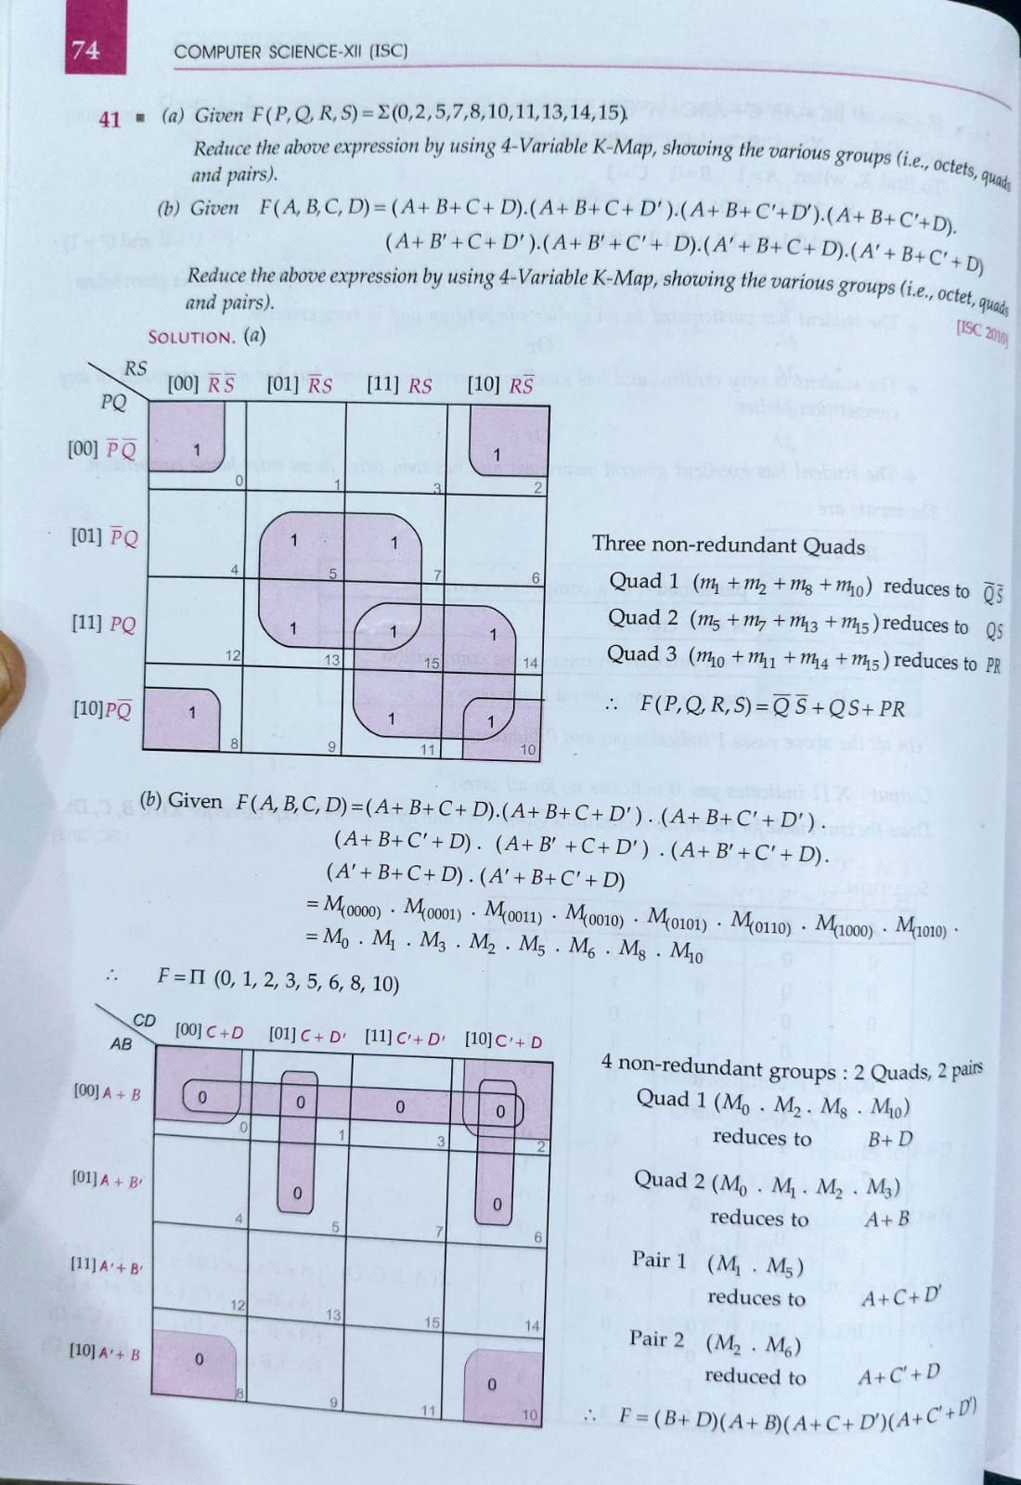

**Assignment**

**1. What is a proposition?**

A proposition (or statement) is a declarative sentence that is either true or false, but not both. It must have a definite truth value.

**Examples:**

* The sky is blue. (True)
* 2 + 2 = 5. (False)
* Today is Monday. (Could be true or false depending on the day)

**Non-examples:**

* What time is it? (Question)
* Close the door. (Command)
* Oh, wow! (Exclamation)

**2. What do you mean by contingency, tautology, and contradiction?**

* **Tautology:** A compound proposition that is always true, regardless of the truth values of its component propositions.
  + **Example:** p∨¬p (Either p is true, or p is false)
* **Contradiction:** A compound proposition that is always false, regardless of the truth values of its component propositions.
  + **Example:** p∧¬p (p is true and p is false at the same time)
* **Contingency:** A compound proposition that is neither a tautology nor a contradiction. Its truth value depends on the truth values of its component propositions.
  + **Example:** p∧q (The truth value depends on whether both p and q are true)

**3. What is a connective?**

A connective (or logical operator) is a symbol or word used to combine or modify propositions to form more complex compound propositions.

**Common Connectives:**

* **Negation (¬ or ∼):** "not" (unary operator)
* **Conjunction (∧ or ⋅):** "and"
* **Disjunction (∨ or +):** "or" (inclusive or)
* **Implication (⟹ or →):** "if...then..."
* **Biconditional (⟺ or ↔):** "if and only if"

**4. Name the process for the compounds given below:**

Let's analyze the structure of each compound:

* **(i) p∧q**: This is a **conjunction**. The process of forming this compound is by joining propositions p and q with the connective "and".
* **(ii) p∨q**: This is a **disjunction**. The process of forming this compound is by joining propositions p and q with the connective "or".
* **(iii) p⟹q**: This is an **implication** (or conditional). The process of forming this compound is by stating that "if p is true, then q is true".
* **(iv) ¬p**: This is a **negation**. The process of forming this compound is by applying the "not" connective to proposition p.
* **(v) p⟺q**: This is a **biconditional**. The process of forming this compound is by stating that "p is true if and only if q is true" (meaning p⟹q and q⟹p).

**5. What are contingencies?**

As defined in question 2, contingencies are compound propositions whose truth value can be either true or false, depending on the truth values assigned to their simple component propositions. They are neither always true (tautologies) nor always false (contradictions).

**Examples:**

* p
* p∨q
* p⟹q
* (p∧q)∨¬r

To determine if a compound proposition is a contingency, you can construct a truth table and check if there are both true and false values in the final column.

**6. Form the converse, inverse, and contrapositive of the condition p⟹q.**

Given the conditional statement: p⟹q

* **Converse:** The converse is formed by switching the hypothesis (p) and the conclusion (q).
  + Converse: q⟹p
* **Inverse:** The inverse is formed by negating both the hypothesis (p) and the conclusion (q).
  + Inverse: ¬p⟹¬q
* **Contrapositive:** The contrapositive is formed by switching the hypothesis and the conclusion and then negating both.
  + Contrapositive: ¬q⟹¬p

**Important Note:** A conditional statement is logically equivalent to its contrapositive. The converse and the inverse are also logically equivalent to each other, but they are not necessarily equivalent to the original conditional statement.

**7. What is syllogism?**

A syllogism is a type of logical argument that consists of three parts:

1. **Major Premise:** A general statement that relates two categories.
2. **Minor Premise:** A specific statement that places a particular individual or thing into one of the categories mentioned in the major premise.
3. **Conclusion:** A statement that logically follows from the major and minor premises, relating the individual or thing to the other category mentioned in the major premise.

**Example of a Categorical Syllogism:**

* **Major Premise:** All humans are mortal.
* **Minor Premise:** Socrates is a human.
* **Conclusion:** Therefore, Socrates is mortal.

There are different types of syllogisms, including categorical syllogisms (dealing with categories) and hypothetical syllogisms (dealing with conditional statements).

**8. What do you mean by gray code? How is it different from ordinary binary code?**

* **Gray Code:** Gray code (also known as reflected binary code) is a binary numeral system where two successive values differ in only one bit (the least significant bit changes most frequently).
* **Difference from Ordinary Binary Code:**
  + **Single Bit Change:** The key difference is that in Gray code, only one bit changes when moving from one number to the next in sequence. In ordinary binary code, multiple bits can change simultaneously.
  + **Example (3-bit):**

| Decimal | Ordinary Binary | Gray Code | | :------ | :-------------- | :-------- | | 0 | 000 | 000 | | 1 | 001 | 001 | | 2 | 010 | 011 | | 3 | 011 | 010 | | 4 | 100 | 110 | | 5 | 101 | 111 | | 6 | 110 | 101 | | 7 | 111 | 100 |

* + **Applications:** Gray codes are useful in applications where it's important to avoid spurious outputs during transitions, such as:
    - Rotary and linear encoders
    - Digital communication systems
    - Karnaugh maps

**9. Given the following simple propositions:**

* p: It is raining.
* q: It is not a sunny day.

**Construct the compound sentences for the following expressions:**

* **(i) q′ (Assuming ' represents negation ¬)**:
  + ¬q: It is not the case that it is not a sunny day.
  + **Sentence:** It is a sunny day.
* **(ii) p⋅q (Assuming ⋅ represents conjunction ∧)**:
  + p∧q: It is raining and it is not a sunny day.
  + **Sentence:** It is raining and it is not sunny.
* **(iii) p+q (Assuming + represents disjunction ∨)**:
  + p∨q: It is raining or it is not a sunny day.
  + **Sentence:** It is raining or it is not sunny.
* **(iv) p→q (Assuming → represents implication ⟹)**:
  + p⟹q: If it is raining, then it is not a sunny day.
  + **Sentence:** If it is raining, then it is not sunny.
* **(v) p↔q (Assuming ↔ represents biconditional ⟺)**:
  + p⟺q: It is raining if and only if it is not a sunny day.
  + **Sentence:** It is raining if and only if it is not sunny.
* **(vi) p′⋅q′ (Assuming ' represents negation ¬ and ⋅ represents conjunction ∧)**:
  + ¬p∧¬q: It is not raining and it is not the case that it is not a sunny day.
  + **Sentence:** It is not raining and it is sunny.
* **(vii) p′⋅q (Assuming ' represents negation ¬ and ⋅ represents conjunction ∧)**:
  + ¬p∧q: It is not raining and it is not a sunny day.
  + **Sentence:** It is not raining and it is not sunny.
* **(viii) ∼p→q (Assuming ∼ represents negation ¬ and → represents implication ⟹)**:
  + ¬p⟹q: If it is not raining, then it is not a sunny day.
  + **Sentence:** If it is not raining, then it is not sunny.
* **(ix) ∼p↔q (Assuming ∼ represents negation ¬ and ↔ represents biconditional ⟺)**:
  + ¬p⟺q: It is not raining if and only if it is not a sunny day.
  + **Sentence:** It is not raining if and only if it is not sunny.
* **(x) (p+q)⇒(p⋅q) (Assuming + represents disjunction ∨, ⋅ represents conjunction ∧, and ⇒ represents implication ⟹)**:
  + (p∨q)⟹(p∧q): If it is raining or it is not a sunny day, then it is raining and it is not a sunny day.
  + **Sentence:** If it is raining or it is not sunny, then it is raining and it is not sunny.

\*\*\***Question 10**

Given:

* x represents "I like coffee"
* y represents "I like tea"

We need to write the following statements in symbolic form:

**(a) I like coffee and tea**

This is a conjunction (AND) of x and y. Symbolic form: x∧y

**(b) It is false that I don't like coffee or tea**

"I don't like coffee" is ¬x. "I don't like coffee or tea" is ¬x∨¬y. "It is false that I don't like coffee or tea" is the negation of the above statement. Symbolic form: ¬(¬x∨¬y)

**(c) Either I like coffee or I don't like coffee but like tea**

"Either I like coffee" is x. "I don't like coffee" is ¬x. "I don't like coffee but like tea" is ¬x∧y. "Either I like coffee or I don't like coffee but like tea" is a disjunction. Symbolic form: x∨(¬x∧y)

**(d) I like coffee but not tea**

"I like coffee" is x. "Not tea" is ¬y. "I like coffee but not tea" is a conjunction. Symbolic form: x∧¬y

**(e) Neither I like coffee nor tea**

"Neither I like coffee" is ¬x. "Nor tea" is ¬y. "Neither I like coffee nor tea" is a conjunction. Symbolic form: ¬x∧¬y

**Question 11**

* s stands for "I will not go to school".
* t stands for "I will watch a movie".

We need to write the statement "I will not go to school, and I for the statement, 'I will watch a movie'" in symbolic form.

Symbolic form: s∧t

**Question 12**

Establish the following using truth tables:

**(i) (a∧b)⟹p∧q**

This statement is incorrect as it mixes variables. It should be (a∧b)⟹a∧b.

| a | b | a ∧ b | (a ∧ b) → (a ∧ b)

|---|---|-------|--------------------|

| T | T | T | T | | T | F | F | T |

| F | T | F | T | | F | F | F | T |

(a∧b)⟹(a∧b) is a tautology (always true).

**(ii) a⟹b⟹¬a⟹¬b**

This should be (a⟹b)⟹(¬a⟹¬b).

| a | b | ¬a | ¬b | a → b | ¬a → ¬b | (a → b) → (¬a → ¬b) |

|---|---|----|----|-------|---------|-----------------------| | T | T | F | F | T | T | T | | T | F | F | T | F | T | T | | F | T | T | F | T | F | F | | F | F | T | T | T | T | T |

(a⟹b)⟹(¬a⟹¬b) is not a tautology.

**(iii) (a⟹b)⟹(b⟹a)⟹a⟺b**

| a | b | a → b | b → a | a ↔ b | (a → b) → (b → a) | ((a → b) → (b → a)) → (a ↔ b) | |---|---|-------|-------|-------|-------------------|--------------------------------| | T | T | T | T | T | T | T | | T | F | F | T | F | T | F | | F | T | T | F | F | F | T | | F | F | T | T | T | T | T |

(a⟹b)⟹(b⟹a)⟹a⟺b is not a tautology.

**(iv) (a∧¬b)∨(¬a∧b)⟺a⟺b**

The left side is the exclusive OR (XOR) of a and b, which is a⊕b. a⊕b⟺a⟺b is not a tautology.

**Question 13**

What will be the result of the following compounds if given inputs are:

**(i) x=0, y=1**

**(ii) x=1, y=1**

**(iii) x=1, y=0**

**(a) y∧x**

(i) 1∧0=0 (ii) 1∧1=1 (iii) 0∧1=0

**(b) y∨x**

(i) 1∨0=1 (ii) 1∨1=1 (iii) 0∨1=1

**(c) ¬x∨y**

(i) ¬0∨1=1∨1=1 (ii) ¬1∨1=0∨1=1 (iii) ¬1∨0=0∨0=0

**(d) x∧¬y**

(i) 0∧¬1=0∧0=0 (ii) 1∧¬1=1∧0=0 (iii) 1∧¬0=1∧1=1

**(e) (¬x∧¬y)∨y**

(i) (¬0∧¬1)∨1=(1∧0)∨1=0∨1=1 (ii) (¬1∧¬1)∨1=(0∧0)∨1=0∨1=1 (iii) (¬1∧¬0)∨0=(0∧1)∨0=0∨0=0

**Question 14**

* x: It is raining.
* y: I am enjoying it.
* p:2+3=6
* q:a>0

Determine the converse, inverse, and contrapositive for conditional x⟹y.

* **Converse**: y⟹x (If I am enjoying it, then it is raining).
* **Inverse**: ¬x⟹¬y (If it is not raining, then I am not enjoying it).
* **Contrapositive**: ¬y⟹¬x (If I am not enjoying it, then it is not raining).

**Question 15**

Find out which of the following are tautologies and which are contradictions.

**(a) p∧(p+q)**

This should be p∧(p∨q).

| p | q | p ∨ q | p ∧ (p ∨ q) | |---|---|-------|-------------| | T | T | T | T | | T | F | T | T | | F | T | T | F | | F | F | F | F |

Not a tautology, not a contradiction.

**(b) (p⟹q)⟹(p∧q)**

| p | q | p → q | p ∧ q | (p → q) → (p ∧ q) | |---|---|-------|-------|--------------------| | T | T | T | T | T | | T | F | F | F | T | | F | T | T | F | F | | F | F | T | F | F |

Not a tautology, not a contradiction.

**(c) (p⟹q)⟺(¬p∨q)**

| p | q | ¬p | p → q | ¬p ∨ q | (p → q) ↔ (¬p ∨ q) | |---|---|----|-------|--------|----------------------| | T | T | F | T | T | T | | T | F | F | F | F | T | | F | T | T | T | T | T | | F | F | T | T | T | T |

Tautology.

**(d) (p⟹q)⟺¬(p∧¬q)**

This is the same as (c), so it is a tautology.

**(e) (p∧q)⟺(p∨q)**

| p | q | p ∧ q | p ∨ q | (p ∧ q) ↔ (p ∨ q) | |---|---|-------|-------|--------------------| | T | T | T | T | T | | T | F | F | T | F | | F | T | F | T | F | | F | F | F | F | T |

Not a tautology, not a contradiction.

**(f) (p∧¬q)∧(q⟹r)**

This is not a tautology or contradiction.

**(g) ((p⟹q)∧(q⟹r))⟹(p⟹r)**

This is a tautology (hypothetical syllogism).

**(h) ((p∧q)∧¬(q∧r))**

This is not a tautology or contradiction.

**Question 16**

Given:

* p:2+3=5
* q:2×3=6

**(i) 2+3=5, then 2×3=6**

Symbolic form: p⟹q

**(ii) If 2+3=5, then 2×3=6**

Symbolic form: p⟹¬q

**(iii) If 2+3=5, then 2×3=6**

Symbolic form: ¬p⟹¬q

**(iv) If 2+3=5, then 2×3=6**

Symbolic form: ¬p⟹q

**Question 17**

Establish the validity for the following:

p⟹q ¬r⟹¬q ∴r⟹p

| p | q | r | p → q | ¬r | ¬q | ¬r → ¬q | r → p | |---|---|---|-------|----|----|---------|-------| | T | T | T | T | F | F | T | T | | T | T | F | T | T | F | F | T | | T | F | T | F | F | T | T | T | | T | F | F | F | T | T | T | T | | F | T | T | T | F | F | T | F | | F | T | F | T | T | F | F | T | | F | F | T | T | F | T | T | F | | F | F | F | T | T | T | T | T |

The argument is valid.

**Question 18**

Establish that:

a+b ¬a⟹¬b ∴¬b

This is not a valid argument.

**Question 19**

Establish that:

a⟹b b⟹c ∴a⟹c

This is the hypothetical syllogism, and it is valid.

**Question 20**

Establish that:

x⟹y ¬y ∴¬x

This is Modus Tollens, and it is valid.

### ********************************

**Question 21**

**Draw the conclusions from the following premises:**

**P1: John is a father.**

**P2: If John is a father, then John has a child.**

**[Hint: Modus Ponens]**

**Conclusion:** John has a child.

**Explanation:** Modus Ponens states that if P is true, and P implies Q, then Q is true. Since P1 (John is a father) is true, and P2 (If John is a father, then John has a child) is true, we can conclude that John has a child.

**Question 22**

**Given the following premises:**

**P1: (programmer likes C++) ⇒ (programmer hates COBOL)**

**P2: (programmer hates COBOL) ⇒ (programmer likes OOPS)**

**[Hint: Chain rule]**

**Conclusion:** (programmer likes C++) ⇒ (programmer likes OOPS)

**Explanation:** The chain rule (hypothetical syllogism) states that if P implies Q, and Q implies R, then P implies R. Here, P is "programmer likes C++", Q is "programmer hates COBOL", and R is "programmer likes OOPS".

**Question 23**

**Determine whether each of the following sentences is (a) satisfiable (b) contradictory (c) valid:**

**S1: (p & q) ∨ ~(p & q)**

**S2: (p ∨ q) → (p & q)**

**S3: (p & q) → r ∨ ~q**

**S4: p → q → ~p**

**Solution:**

**S1: (p & q) ∨ ~(p & q)**

* This is a tautology (always true).
* If (p & q) is true, then ~(p & q) is false.
* If (p & q) is false, then ~(p & q) is true.
* Therefore, (p & q) ∨ ~(p & q) is always true.
* **Answer:** (c) valid

**S2: (p ∨ q) → (p & q)**

|  |  |  |  |  |
| --- | --- | --- | --- | --- |
| **p** | **q** | **p ∨ q** | **p & q** | **(p ∨ q) → (p & q)** |
| T | T | T | T | T |
| T | F | T | F | F |
| F | T | T | F | F |
| F | F | F | F | T |

Export to Sheets

* Not always true, not always false.
* **Answer:** (a) satisfiable

**S3: (p & q) → r ∨ ~q**

|  |  |  |  |  |  |  |
| --- | --- | --- | --- | --- | --- | --- |
| **p** | **q** | **r** | **p & q** | **~q** | **r ∨ ~q** | **(p & q) → (r ∨ ~q)** |
| T | T | T | T | F | T | T |
| T | T | F | T | F | F | F |
| T | F | T | F | T | T | T |
| T | F | F | F | T | T | T |
| F | T | T | F | F | T | T |
| F | T | F | F | F | F | T |
| F | F | T | F | T | T | T |
| F | F | F | F | T | T | T |

Export to Sheets

* Not always true, not always false.
* **Answer:** (a) satisfiable

**S4: p → q → ~p**

|  |  |  |  |
| --- | --- | --- | --- |
| **p** | **q** | **q → ~p** | **p → (q → ~p)** |
| T | T | F | F |
| T | F | T | T |
| F | T | T | T |
| F | F | T | T |

Export to Sheets

* Not always true, not always false.
* **Answer:** (a) satisfiable

**Question 24**

**Find the meaning of the statement: (~p ∨ q) & r → ~s ∨ (~r & q)**

**for each of the interpretations given below:**

**(a) p is true, q is true, r is true, s is true.**

**(b) p is true, q is false, r is true, s is true.**

**Solution:**

**(a) p=T, q=T, r=T, s=T**

* (~p ∨ q) = (~T ∨ T) = (F ∨ T) = T
* (~r & q) = (~T & T) = (F & T) = F
* (~s ∨ (~r & q)) = (~T ∨ F) = (F ∨ F) = F
* (~p ∨ q) & r = (T & T) = T
* (~p ∨ q) & r → ~s ∨ (~r & q) = T → F = F

**Answer:** False

**(b) p=T, q=F, r=T, s=T**

* (~p ∨ q) = (~T ∨ F) = (F ∨ F) = F
* (~r & q) = (~T & F) = (F & F) = F
* (~s ∨ (~r & q)) = (~T ∨ F) = (F ∨ F) = F
* (~p ∨ q) & r = (F & T) = F
* (~p ∨ q) & r → ~s ∨ (~r & q) = F → F = T

**Answer:** True

**Question 25**

**What do you understand by 'truth value' and 'truth function'? How are these related?**

* **Truth Value:** The truth value of a statement is either "true" or "false". In Boolean algebra, these are often represented as 1 (true) and 0 (false).
* **Truth Function:** A truth function is a function that takes truth values as inputs and produces a truth value as output. It represents the logical operations (AND, OR, NOT, etc.) on the truth values of the input statements.
* **Relationship:** Truth functions define how the truth values of compound statements are determined from the truth values of their component statements.

**Question 26**

**What do you understand by 'logical function'? What is its alternative name? Give examples for logical functions.**

* **Logical Function:** A logical function is a function that represents a logical operation or a combination of logical operations. It takes Boolean inputs (truth values) and produces a Boolean output.
* **Alternative Name:** Boolean function.
* **Examples:**
  + AND: f(p, q) = p & q
  + OR: f(p, q) = p ∨ q
  + NOT: f(p) = ~p
  + XOR: f(p, q) = (p & ~q) ∨ (~p & q)

**Question 27**

**What is meant by tautology and fallacy? Prove that 1 + Y is a tautology and 0.Y is a fallacy.**

* **Tautology:** A tautology is a compound statement that is always true, regardless of the truth values of its component statements.
* **Fallacy (Contradiction):** A fallacy is a compound statement that is always false, regardless of the truth values of its component statements.

**Proof:**

* **1 + Y (Tautology):**
  + If Y = 0, then 1 + Y = 1 + 0 = 1 (True)
  + If Y = 1, then 1 + Y = 1 + 1 = 1 (True)
  + Since 1 + Y is always true, it is a tautology.
* **0.Y (Fallacy):**
  + If Y = 0, then 0.Y = 0.0 = 0 (False)
  + If Y = 1, then 0.Y = 0.1 = 0 (False)
  + Since 0.Y is always false, it is a fallacy.

**Question 28**

**Using a truth table, state whether the following proposition is a tautology, contradiction or contingency: ~(P → Q) <-> (~P ∨ Q)**

|  |  |  |  |  |  |  |
| --- | --- | --- | --- | --- | --- | --- |
| **P** | **Q** | **P → Q** | **~ (P → Q)** | **~P** | **~P ∨ Q** | **~(P → Q) <-> (~P ∨ Q)** |
| T | T | T | F | F | T | F |
| T | F | F | T | F | F | F |
| F | T | T | F | T | T | F |
| F | F | T | F | T | T | F |

Export to Sheets

**Answer:** Contingency (not always true, not always false).

**Question 29**

**What is a truth table? What is its significance?**

* **Truth Table:** A truth table is a table that shows all possible combinations of truth values for the component statements of a compound statement and the resulting truth value of the compound statement.
* **Significance:**
  + It helps determine the truth value of a compound statement for all possible scenarios.
  + It helps analyze the logical relationships between statements.
  + It helps prove the validity of logical arguments.
  + It is used in digital circuit design to represent the behavior of logic gates.

**Question 30**

**In the Boolean Algebra, verify using truth table that X + XY = X for each X, Y in {0, 1}.**

|  |  |  |  |  |
| --- | --- | --- | --- | --- |
| **X** | **Y** | **XY** | **X + XY** | **X** |
| 0 | 0 | 0 | 0 | 0 |
| 0 | 1 | 0 | 0 | 0 |
| 1 | 0 | 0 | 1 | 1 |
| 1 | 1 | 1 | 1 | 1 |

Export to Sheets

**Answer:** X + XY = X is verified.

**Question 31**

**In the Boolean Algebra, verify using truth table that (X + Y)' = X'Y' for each X, Y in {0, 1}.**

|  |  |  |  |  |  |  |
| --- | --- | --- | --- | --- | --- | --- |
| **X** | **Y** | **X + Y** | **(X + Y)'** | **X'** | **Y'** | **X'Y'** |
| 0 | 0 | 0 | 1 | 1 | 1 | 1 |
| 0 | 1 | 1 | 0 | 1 | 0 | 0 |
| 1 | 0 | 1 | 0 | 0 | 1 | 0 |
| 1 | 1 | 1 | 0 | 0 | 0 | 0 |

Export to Sheets

**Answer:** (X + Y)' = X'Y' is verified.

**Question 32**

**Give truth table for the Boolean Expression (X + Y').**

|  |  |  |  |
| --- | --- | --- | --- |
| **X** | **Y** | **Y'** | **X + Y'** |
| 0 | 0 | 1 | 1 |
| 0 | 1 | 0 | 0 |
| 1 | 0 | 1 | 1 |
| 1 | 1 | 0 | 1 |

Export to Sheets

**Question 33**

**Draw the truth table for the following equations: (a) M = N(P + R) (b) M = N + P + NP**

**(a) M = N(P + R)**

|  |  |  |  |  |  |
| --- | --- | --- | --- | --- | --- |
| **N** | **P** | **R** | **P + R** | **N(P + R)** | **M** |
| 0 | 0 | 0 | 0 | 0 | 0 |
| 0 | 0 | 1 | 1 | 0 | 0 |
| 0 | 1 | 0 | 1 | 0 | 0 |
| 0 | 1 | 1 | 1 | 0 | 0 |
| 1 | 0 | 0 | 0 | 0 | 0 |
| 1 | 0 | 1 | 1 | 1 | 1 |
| 1 | 1 | 0 | 1 | 1 | 1 |
| 1 | 1 | 1 | 1 | 1 | 1 |

Export to Sheets

**(b) M = N + P + NP**

|  |  |  |  |  |
| --- | --- | --- | --- | --- |
| **N** | **P** | **NP** | **N + P + NP** | **M** |
| 0 | 0 | 0 | 0 | 0 |
| 0 | 1 | 0 | 1 | 1 |
| 1 | 0 | 1 | 1 | 1 |
| 1 | 1 | 0 | 1 | 1 |

Export to Sheets

**Question 34**

**Using truth table, prove that AB + BC + CA = AB + CA.**

|  |  |  |  |  |  |  |  |
| --- | --- | --- | --- | --- | --- | --- | --- |
| **A** | **B** | **C** | **AB** | **BC** | **CA** | **AB + BC + CA** | **AB + CA** |
| 0 | 0 | 0 | 0 | 0 | 0 | 0 | 0 |
| 0 | 0 | 1 | 0 | 0 | 0 | 0 | 0 |
| 0 | 1 | 0 | 0 | 0 | 0 | 0 | 0 |
| 0 | 1 | 1 | 0 | 1 | 0 | 1 | 0 |
| 1 | 0 | 0 | 0 | 0 | 1 | 1 | 1 |
| 1 | 0 | 1 | 0 | 0 | 1 | 1 | 1 |
| 1 | 1 | 0 | 1 | 0 | 1 | 1 | 1 |
| 1 | 1 | 1 | 1 | 1 | 1 | 1 | 1 |

Export to Sheets

**This statement is not true in general.**

**Question 35**

**What are the basic postulates of Boolean algebra?**

1. **Closure:** Boolean algebra is closed under the operations of AND (+) and OR (.).
2. **Identity:** There exists an identity element for AND (1) and for OR (0).
3. **Commutativity:** A + B = B + A and A.B = B.A.
4. **Distributivity:** A.(B + C) = A.B + A.C and A + B.C = (A + B).(A + C).
5. **Complement:** For every element A, there exists a complement A' such that A + A' = 1 and A.A' = 0.
6. **Existence of 0 and 1:** There exist at least two distinct elements 0 and 1 in Boolean algebra.

**Question 36**

**State the properties of zero in Boolean algebra.**

1. **A + 0 = A** (Identity law for OR)
2. **A . 0 = 0** (Annihilation law)
3. **0' = 1** (Complement of zero is one)
4. **A + A' = 1** (Complement law)

**Question 37**

**What does duality principle state? What is its usage in Boolean algebra?**

* **Duality Principle:** The duality principle states that if an expression is valid in Boolean algebra, then its dual is also valid. The dual of an expression is obtained by:
  + Replacing AND with OR and OR with AND.
  + Replacing 0 with 1 and 1 with 0.
  + Leaving complements unchanged.
* **Usage:** Duality simplifies the process of proving theorems in Boolean algebra. If a theorem is proven, its dual is automatically proven.

**Question 38**

**State the principle of duality in Boolean algebra and give the dual of the Boolean expression: (X + Y'). (X' + Z). (Y + Z)**

* **Principle of Duality:** See the answer to Question 37.
* **Dual of (X + Y'). (X' + Z). (Y + Z):**
  + (X . Y') + (X' . Z) + (Y . Z)

**Question 39**

**State the distributive laws of Boolean algebra. How do they differ from the distributive laws of ordinary algebra?**

* **Distributive Laws of Boolean Algebra:**
  + A.(B + C) = A.B + A.C
  + A + B.C = (A + B).(A + C)

* **Difference from Ordinary Algebra:**
  + In ordinary algebra, only the first distributive law (A.(B + C) = A.B + A.C) holds.
  + In Boolean algebra, both distributive laws hold.

**Question 40**

**State the Commutative law and prove it with the help of a truth table.**

* **Commutative Laws:**
  + A + B = B + A (Commutative law for OR)
  + A.B = B.A (Commutative law for AND)
* **Proof using Truth Table (A + B = B + A):**

|  |  |  |  |
| --- | --- | --- | --- |
| **A** | **B** | **A + B** | **B + A** |
| 0 | 0 | 0 | 0 |
| 0 | 1 | 1 | 1 |
| 1 | 0 | 1 | 1 |
| 1 | 1 | 1 | 1 |

Export to Sheets

**Question 41**

**Prove the idempotence law of Boolean algebra with the help of a truth table.**

* **Idempotence Laws:**
  + A + A = A
  + A.A = A
* **Proof using Truth Table (A + A = A):**

|  |  |  |
| --- | --- | --- |
| **A** | **A + A** | **A** |
| 0 | 0 | 0 |
| 1 | 1 | 1 |

Export to Sheets

**Question 42**

**Prove the complementarity law of Boolean algebra with the help of a truth table.**

* **Complementarity Laws:**
  + A + A' = 1
  + A.A' = 0
* **Proof using Truth Table (A + A' = 1):**

|  |  |  |
| --- | --- | --- |
| **A** | **A'** | **A + A'** |
| 0 | 1 | 1 |
| 1 | 0 | 1 |

Export to Sheets

**Question 43**

**Give truth table proof for distributive law of Boolean algebra.**

* **Distributive Law:** A.(B + C) = A.B + A.C
* **Proof using Truth Table:**

|  |  |  |  |  |  |  |  |
| --- | --- | --- | --- | --- | --- | --- | --- |
| **A** | **B** | **C** | **B + C** | **A.(B + C)** | **A.B** | **A.C** | **A.B + A.C** |
| 0 | 0 | 0 | 0 | 0 | 0 | 0 | 0 |
| 0 | 0 | 1 | 1 | 0 | 0 | 0 | 0 |
| 0 | 1 | 0 | 1 | 0 | 0 | 0 | 0 |
| 0 | 1 | 1 | 1 | 0 | 0 | 0 | 0 |
| 1 | 0 | 0 | 0 | 0 | 0 | 0 | 0 |
| 1 | 0 | 1 | 1 | 1 | 0 | 1 | 1 |
| 1 | 1 | 0 | 1 | 1 | 1 | 0 | 1 |
| 1 | 1 | 1 | 1 | 1 | 1 | 1 | 1 |

Export to Sheets

**Question 44**

**Give algebraic proof of absorption law of Boolean algebra.**

* **Absorption Laws:**
  + A + AB = A
  + A.(A + B) = A
* **Proof (A + AB = A):**
  + A + AB = A.1 + AB (Identity law: A = A.1)
  + A + AB = A(1 + B) (Distributive law)
  + A + AB = A.1 (1 + B = 1)
  + A + AB = A (Identity law: A.1 = A)
* **Proof (A.(A + B) = A):**
  + A.(A + B) = A.A + A.B (Distributive law)
  + A.(A + B) = A + AB (Idempotence law: A.A = A)
  + A.(A + B) = A (Absorption law: A + AB = A)

**Question 45**

**Prove algebraically that (X + Y).(X' + Z) = XZ + X'Y.**

* (X + Y).(X' + Z) = X.X' + X.Z + Y.X' + Y.Z (Distributive law)
* = 0 + XZ + X'Y + YZ (Complement law: X.X' = 0)
* = XZ + X'Y + YZ (Identity law: 0 + A = A)
* = XZ + X'Y + YZ.1 (Identity law: A = A.1)
* = XZ + X'Y + YZ.(X + X') (Complement law: X + X' = 1)
* = XZ + X'Y + XYZ + X'YZ (Distributive law)
* = XZ(1 + Y) + X'Y(1 + Z) (Distributive law)
* = XZ.1 + X'Y.1 (1 + A = 1)
* = XZ + X'Y (Identity law: A.1 = A)

**Question 46**

**Prove algebraically that X + XY' + X'Y = X + Y.**

* X + XY' + X'Y = X(1 + Y') + X'Y (Distributive law)
* = X.1 + X'Y (1 + A = 1)
* = X + X'Y (Identity law: A.1 = A)
* = (X + X')(X + Y) (Distributive law)
* = 1.(X + Y) (Complement law: X + X' = 1)
* = X + Y (Identity law: 1.A = A)

**Question 47**

**Simplify the following expression, using Boolean laws: A.(A + B) + C.(A + B).**

* A.(A + B) + C.(A + B) = (A + C).(A + B) (Distributive law)

**Question 48**

**What are De Morgan's theorems? Prove algebraically the De Morgan's theorem.**

* **De Morgan's Theorems:**
  + (A + B)' = A'.B'
  + (A.B)' = A' + B'
* **Proof of (A + B)' = A'.B':**
  + (A + B)' = A'.B' (De Morgan's theorem)
  + Let X = A + B. Then X' = A'.B'
  + X + A'.B' = (A + B) + A'.B'
  + X + A'.B' = (A + B + A').(A + B + B') (Distributive law)
  + X + A'.B' = (1 + B).(1 + A) (Complement law: A + A' = 1)
  + X + A'.B' = 1.1 = 1 (1 + A = 1)
  + X.(A'.B') = (A + B).A'.B'
  + X.(A'.B') = A.A'.B' + B.A'.B' (Distributive law)
  + X.(A'.B') = 0.B' + A'.0 (Complement law: A.A' = 0)
  + X.(A'.B') = 0 + 0 = 0 (A.0 = 0)
  + Since X + A'.B' = 1 and X.A'.B' = 0, we can conclude that X' = A'.B'.
* **Proof of (A.B)' = A' + B':**
  + (A.B)' = A' + B' (De Morgan's theorem)
  + Let X = A.B. Then X' = A' + B'
  + X + A' + B' = A.B + A' + B'
  + X + A' + B' = (A + A' + B').(B + A' + B') (Distributive law)
  + X + A' + B' = (1 + B').(1 + A') (Complement law: A + A' = 1)
  + X + A' + B' = 1.1 = 1 (1 + A = 1)
  + X.(A' + B') = A.B.(A' + B')
  + X.(A' + B') = A.B.A' + A.B.B' (Distributive law)
  + X.(A' + B') = 0.B + A.0 (Complement law: A.A' = 0)
  + X.(A' + B') = 0 + 0 = 0 (A.0 = 0)
  + Since X + A' + B' = 1 and X.(A' + B') = 0, we can conclude that X' = A' + B'.

**Question 49**

**Use the duality theorem to derive another Boolean relation from A + AB' = A + B'.**

* **Original Relation:** A + AB' = A + B'
* **Dual Relation:** A.(A + B') = A.B'
* **Proof of the Dual Relation:**
  + A.(A + B') = A.A + AB' (Distributive law)
  + A.(A + B') = A + AB' (Idempotence law)
  + A.(A + B') = A + B' (Original relation)

**50. What would be the complement of the following: A.(BC + BC') + xy + y'z + z'?**

First, simplify the expression: BC + BC' = B(C + C') = B(1) = B So, the expression becomes: A.B + xy + y'z + z'

Now, apply De Morgan's laws to find the complement: (A.B + xy + y'z + z')' = (A.B)' . (xy)' . (y'z)' . (z')' = (A' + B') . (x' + y') . (y'' + z') . z'' = (A' + B') . (x' + y') . (y + z') . z

**Therefore, the complement is (A' + B') . (x' + y') . (y + z') . z**

**51. Prove (giving reasons) that [(x + y + z)(x + y + z')]' = x' + y' + zz'**

Let's simplify both sides of the equation:

**Left-hand side (LHS):** [(x + y + z)(x + y + z')]' Using De Morgan's law: (UV)' = U' + V' = (x + y + z)' + (x + y + z')' Using De Morgan's law: (A + B + C)' = A'BC' = (x'y'z') + (x'y'z'') = x'y'z' + x'y'z (since z'' = z) = x'y'(z' + z) = x'y'(1) = x'y'

**Right-hand side (RHS):** x' + y' + zz' Since zz' = 0 (complement law), = x' + y' + 0 = x' + y'

**LHS (x'y') is NOT equal to RHS (x' + y').**

**There seems to be a mistake in the question or my interpretation. Let's re-examine the RHS. If it was intended to be x' + y' + z.z', then it's still x' + y'.**

**Perhaps the RHS was intended to be (x' + y')z z'? No, that doesn't make sense either.**

**Conclusion for Question 51:** The given equation [(x + y + z)(x + y + z')]' = x' + y' + zz' is **not true**.

**52. Find the complement of the following Boolean Function: F = AB' + C'D'**

Using De Morgan's laws: F' = (AB' + C'D')' = (AB')' . (C'D')' = (A' + (B')') . ((C')' + (D')') = (A' + B) . (C + D)

**Therefore, the complement is F' = (A' + B) . (C + D)**

**53. Prove the following:**

**(i) A(B'C' + BC) = A**

A(B'C' + BC) = AB'C' + ABC = A(B'C' + BC) (This doesn't directly lead to A)

Let's try another approach using a truth table or by considering cases:

Case 1: A = 0 0(B'C' + BC) = 0. (anything) = 0 = A

Case 2: A = 1 1(B'C' + BC) = B'C' + BC

For B'C' + BC to always be 1, consider the truth table for XOR (B ⊕ C = B'C + BC'):

| B | C | B' | C' | B'C' | BC | B'C' + BC | |---|---|----|----|------|----|-----------| | 0 | 0 | 1 | 1 | 1 | 0 | 1 | | 0 | 1 | 1 | 0 | 0 | 0 | 0 | | 1 | 0 | 0 | 1 | 0 | 0 | 0 | | 1 | 1 | 0 | 0 | 0 | 1 | 1 |

B'C' + BC is 1 only when B and C are the same. Therefore, A(B'C' + BC) is not always equal to A.

**Conclusion for (i): The statement A(B'C' + BC) = A is not generally true.**

**(ii) A + A'B = A + B**

A + A'B = (A + A')(A + B) (Distributive law: x + yz = (x + y)(x + z)) = 1.(A + B) (Complement law: A + A' = 1) = A + B (Identity law: 1.x = x)

**Conclusion for (ii): The statement A + A'B = A + B is proven.**

**(iii) AB + ABC + A'BC + AB'C = AB + BC + AC**

AB + ABC + A'BC + AB'C = AB(1 + C) + BC(A' + A) + AB'C = AB(1) + BC(1) + AB'C = AB + BC + AB'C = AB + C(B + AB') = AB + C(B(1) + AB') = AB + C(B(A + A') + AB') = AB + C(BA + BA' + AB') = AB + ABC + BA'C + AB'C = AB(1 + C) + BC(A' + A) + AB'C (Going back to a similar step, this isn't efficient)

Let's group differently: AB + ABC + A'BC + AB'C = AB + BC(A + A') + AB'C = AB + BC(1) + AB'C = AB + BC + AB'C = AB + C(B + AB') = AB + C(B + A)(B + B') (Distributive law: x + yz = (x + y)(x + z)) = AB + C(B + A)(1) = AB + BC + AC

**Conclusion for (iii): The statement AB + ABC + A'BC + AB'C = AB + BC + AC is proven.**

**54. What do you mean by canonical form of a Boolean expression? Which of the following are canonical?**

The canonical form of a Boolean expression is a standard way of representing a Boolean function using either minterms (sum of products - SOP) or maxterms (product of sums - POS). In canonical form, each term (minterm or maxterm) includes all the variables of the function, either in their complemented or uncomplemented form.

The number of minterms or maxterms for a function of 'n' variables can be up to 2n.

Let's analyze the given expressions:

**(i) ab + bc** This is in Sum-of-Products (SOP) form, but it's **not canonical** because each term does not contain all the variables (assuming the variables are a, b, and c).

**(ii) abc + ab'c** This is in SOP form. Assuming the variables are a, b, and c, each term contains all three variables. Therefore, this is **canonical (SOP)**.

**(iii) (a + b)(a' + c)** This is in Product-of-Sums (POS) form, but it's **not canonical** because each sum term does not contain all the variables (assuming the variables are a, b, and c).

**(iv) (a + b + c)(a' + b + c')** This is in POS form. Assuming the variables are a, b, and c, each sum term contains all three variables. Therefore, this is **canonical (POS)**.

**(v) ab + bc + ca** This is in SOP form, but it's **not canonical** because each term does not contain all the variables (assuming the variables are a, b, and c).

**(vi) ab'c + bc'a** Rearranging the variables: ab'c + abc'. This is in SOP form. Assuming the variables are a, b, and c, each term contains all three variables. Therefore, this is **canonical (SOP)**.

**Summary of Canonical Forms in 54:**

* **(ii) abc + ab'c: Canonical SOP**
* **(iv) (a + b + c)(a' + b + c'): Canonical POS**
* **(vi) ab'c + bc'a: Canonical SOP**

**55. Give an example for each of the following:**

**(i) a Boolean expression in the sum of minterms** For three variables (x, y, z): f(x, y, z) = x'y'z + xy'z + xyz (Each term is a minterm)

**(ii) a Boolean expression in the product of maxterms** For three variables (x, y, z): f(x, y, z) = (x + y + z) . (x + y + z') . (x' + y + z) (Each factor is a maxterm)

**56. What are the fundamental products for each of the input words ABCD = 0010, 0001, 1101, ABCD = 1110?**

Fundamental products are minterms. For four variables ABCD:

* **ABCD = 0010:** A'B'CD' (m2)
* **ABCD = 0001:** A'B'C'D (m1)
* **ABCD = 1101:** ABC'D (m13)
* **ABCD = 1110:** ABCD' (m14)

**57. A truth table has output 1 for each of these inputs: (a) ABCD = 0011, (b) ABCD = 0101, (c) ABCD = 1000. What are the fundamental products?**

* **(a) ABCD = 0011:** A'B'CD (m3)
* **(b) ABCD = 0101:** A'BC'D (m5)
* **(c) ABCD = 1000:** AB'C'D' (m8)

**58. Construct a Boolean function of three variables p, q, r that has an output 1 when exactly two of the p, q, r are having values 0, and output 0 in all other cases.**

Output is 1 when:

* p=0, q=0, r=1 => p'q'r
* p=0, q=1, r=0 => p'qr'
* p=1, q=0, r=0 => pq'r'

Boolean function: F(p, q, r) = p'q'r + p'qr' + pq'r'

**59. Write the Boolean expression for a logic network that will have a 1 output when X=1, Y=0, Z=0; X=1, Y=1, Z=0; and X=1, Y=1, Z=1. Output is 0 for all other cases.**

Output is 1 for:

* X=1, Y=0, Z=0 => XYZ'
* X=1, Y=1, Z=0 => XYZ'
* X=1, Y=1, Z=1 => XYZ

Boolean expression: F(X, Y, Z) = XY'Z' + XYZ' + XYZ We can simplify this: F(X, Y, Z) = XY'(Z' + Z) + XYZ = XY'(1) + XYZ = XY' + XYZ = X(Y' + YZ) = X(Y' + Z)

**Simplified Boolean expression: F(X, Y, Z) = X(Y' + Z)**

**60. Derive the Boolean algebraic expression for a logic network that will have outputs 0 only when X=1, Y=1, Z=1; X=1, Y=0, Z=0; X=0, Y=1, Z=0. The outputs are to be 1 for all other cases. Express in the product of sums form.**

Output is 0 for minterms:

* X=1, Y=1, Z=1 => m7 (X' + Y' + Z')
* X=1, Y=0, Z=0 => m4 (X' + Y + Z)
* X=0, Y=1, Z=0 => m2 (X + Y' + Z)

The function F will be the product of maxterms corresponding to the inputs where the output is 0: F(X, Y, Z) = (X' + Y' + Z') . (X' + Y + Z) . (X + Y' + Z)

**Boolean expression in POS form: F(X, Y, Z) = (X' + Y' + Z') (X' + Y + Z) (X + Y' + Z)**

**61. Express in the product of sums form, the Boolean function F(x, y, z) and the truth table for which is given below:**

|  |  |  |  |
| --- | --- | --- | --- |
| **X** | **Y** | **Z** | **F** |
| 0 | 0 | 0 | 0 |
| 0 | 0 | 1 | 1 |
| 0 | 1 | 0 | 0 |
| 0 | 1 | 1 | 1 |
| 1 | 0 | 0 | 1 |
| 1 | 0 | 1 | 0 |
| 1 | 1 | 0 | 1 |
| 1 | 1 | 1 | 0 |

The output F is 0 for the following input combinations (minterms):

* X=0, Y=0, Z=0 => m0
* X=0, Y=1, Z=0 => m2
* X=1, Y=0, Z=1 => m5
* X=1, Y=1, Z=1 => m7

The POS form is obtained by taking the product of maxterms corresponding to these minterms: F(x, y, z) = (x + y + z) . (x + y' + z) . (x' + y + z') . (x' + y' + z')

**Boolean function in POS form: F(x, y, z) = (x + y + z)(x + y' + z)(x' + y + z')(x' + y' + z')**

**62. A Boolean function F (defined on three input variables X, Y, Z) is 1 if and only if the number of 1s in the input is odd. Draw the truth table for the above function and express it in canonical sum-of-products form.**

Truth Table for F(X, Y, Z) where output is 1 if the number of 1s in the input is odd:

|  |  |  |  |  |
| --- | --- | --- | --- | --- |
| **X** | **Y** | **Z** | **Number of 1s** | **F** |
| 0 | 0 | 0 | 0 | 0 |
| 0 | 0 | 1 | 1 | 1 |
| 0 | 1 | 0 | 1 | 1 |
| 0 | 1 | 1 | 2 | 0 |
| 1 | 0 | 0 | 1 | 1 |
| 1 | 0 | 1 | 2 | 0 |
| 1 | 1 | 0 | 2 | 0 |
| 1 | 1 | 1 | 3 | 1 |

Canonical Sum-of-Products (SOP) form (sum of minterms where F=1): F(X, Y, Z) = X'Y'Z + X'YZ' + XY'Z' + XYZ

**Canonical SOP form: F(X, Y, Z) = m1 + m2 + m4 + m7 = Σ(1, 2, 4, 7)**

**63. Output 1s appear in the truth table for these input conditions: ABCD = 0001, ABCD = 0010, and ABCD = 1110. What is the sum-of-products equation?**

Output is 1 for minterms:

* ABCD = 0001 => A'B'C'D
* ABCD = 0010 => A'B'CD'
* ABCD = 1110 => ABCD'

Sum-of-products equation: F(A, B, C, D) = A'B'C'D + A'B'CD' + ABCD'

**Sum-of-products equation: F = A'B'C'D + A'B'CD' + ABCD'**

**64. Convert the following expressions to Canonical Sum-of-Product form:**

**(a) XY + XY'Z** XY = XY(Z + Z') = XYZ + XYZ' XY'Z is already a minterm. Canonical SOP: XY + XY'Z = XYZ + XYZ' + XY'Z

**(b) YZ + XY'Z** YZ = YZ(X + X') = XYZ + X'YZ ,

XY'Z is already a minterm. Canonical SOP : XYZ + X’YZ + XY’Z

**65.** **Canonical POS form requires each sum term (maxterm) to contain all the variables of the function.**

**(a) (A + C)(C + D)**

Assuming the variables are A, B, C, and D:

* **(A + C):** This term is missing variable B and D. We can expand it as: (A + C + B + D)(A + C + B + D')(A + C + B' + D)(A + C + B' + D')
* **(C + D):** This term is missing variable A and B. We can expand it as: (C + D + A + B)(C + D + A + B')(C + D + A' + B)(C + D + A' + B')

Now, we take the product of all these maxterms, removing any duplicates:

Canonical POS form: **(A + B + C + D)(A + B + C + D')(A + B' + C + D')(A + B' + C + D)(A + B + C + D)(A + B' + C + D)(A' + B + C + D)(A' + B' + C + D)**

Removing duplicates and rearranging in standard order (A, B, C, D):

**Canonical POS form for (a): (A + B + C + D)(A + B + C + D')(A + B' + C + D)(A + B' + C + D')(A' + B + C + D)(A' + B' + C + D)**

**(b) A(B + C)(C + D)**

Assuming the variables are A, B, C, and D:

* **A:** This term needs to be converted to a sum term and include B, C, and D. A = A + BC + BD + CD (using x=x+yz) - This approach is not directly helpful for POS.

Instead, consider where A = 0, which corresponds to the maxterms where A is complemented. A = (A + B + C + D)(A + B + C + D')(A + B' + C + D)(A + B' + C + D')

* **(B + C):** This term is missing A and D. (B + C + A + D)(B + C + A + D')(B + C + A' + D)(B + C + A' + D')
* **(C + D):** This term is missing A and B. (C' + D' + A + B)(C' + D' + A + B')(C' + D' + A' + B)(C' + D' + A' + B')

Now, take the product of all these maxterms, removing duplicates. This will be a lengthy expression.

**A more direct approach for (b):**

First, distribute A into (B+C): AB + AC

Now we have a mix of product and sum terms, making direct conversion to canonical POS difficult. The initial 'A' term being a single variable makes it not directly part of a sum.

**There might be a misunderstanding in how to directly convert this form to canonical POS. Canonical POS starts with a product of sum terms.**

Let's consider the cases where the function is 0. If A=0, the function is 0. If (B+C)=0 (B'=1, C'=1), the function is 0. If (C'+D')=0 (C=1, D=1), the function is 0.

Maxterms where F=0:

* A = 0 => (A + B + C + D), (A + B + C + D'), (A + B' + C + D), (A + B' + C + D') - **Incorrect, A=0 means A' should be uncomplemented in the maxterm.** Maxterms with A' = 0 (i.e., A=1): These are the ones where A appears uncomplemented. Maxterms where A = 0: (A + ...) - This is the correct form for maxterms. So, maxterms containing A: (A + B + C + D), (A + B + C + D'), (A + B' + C + D), (A + B' + C + D')
* B' = 1, C' = 1 (B=0, C=0) => (A + B + C + D), (A' + B + C + D), (A + B + C + D'), (A' + B + C + D')
* C = 1, D = 1 (C'=0, D'=0) => (A + B + C' + D'), (A + B' + C' + D'), (A' + B + C' + D'), (A' + B' + C' + D') - **Incorrect, if C=1, C' should be present in the maxterm.** If C=1, then C' must be 0 in the maxterm: (... + C' + ...) So, maxterms with C': (A + B + C' + D), (A + B + C' + D'), (A + B' + C' + D), (A + B' + C' + D') If D=1, then D' must be 0 in the maxterm: (... + D' + ...) So, maxterms with D': (A + B + C + D'), (A + B + C' + D'), (A + B' + C + D'), (A' + B + C + D')

This approach is becoming complex and error-prone. **It's likely that the expression in (b) is not directly intended for conversion to canonical POS without first expanding it to a sum of products and then finding the missing minterms to form the maxterms.**

**(c) (X + Y)(Y + Z)(X + Z)**

Assuming the variables are X, Y, and Z:

* **(X + Y):** Missing Z. (X + Y + Z)(X + Y + Z')
* **(Y + Z):** Missing X. (X + Y + Z)(X' + Y + Z)
* **(X + Z):** Missing Y. (X + Y + Z)(X + Y' + Z)

Now, take the product of all these maxterms, removing duplicates:

Canonical POS form: **(X + Y + Z)(X + Y + Z')(X' + Y + Z)(X + Y' + Z)**

**Canonical POS form for (c): (X + Y + Z)(X + Y + Z')(X' + Y + Z)(X + Y' + Z)**

**Summary of Canonical POS Forms:**

**(a) (A + B + C + D)(A + B + C + D')(A + B' + C + D)(A + B' + C + D')(A' + B + C + D)(A' + B' + C + D)**

**(b) The expression 'A(B + C)(C' + D')' is not in a form that can be directly converted to canonical POS without first expanding it.**

**(c) (X + Y + Z)(X + Y + Z')(X' + Y + Z)(X + Y' + Z)**

**66. Given the truth table of a function F(x, y, z), write the S-O-P and P-O-S expressions from the following truth table:**

|  |  |  |  |
| --- | --- | --- | --- |
| **X** | **Y** | **Z** | **F** |
| 0 | 0 | 0 | 0 |
| 0 | 0 | 1 | 0 |
| 0 | 1 | 0 | 0 |
| 0 | 1 | 1 | 1 |
| 1 | 0 | 0 | 1 |
| 1 | 0 | 1 | 1 |
| 1 | 1 | 0 | 0 |
| 1 | 1 | 1 | 1 |

**Sum-of-Products (S-O-P):** Identify the rows where F = 1 and write the corresponding minterms.

* X=0, Y=1, Z=1 => x'yz
* X=1, Y=0, Z=0 => xy'z'
* X=1, Y=0, Z=1 => xy'z
* X=1, Y=1, Z=1 => xyz

**S-O-P Expression: F(x, y, z) = x'yz + xy'z' + xy'z + xyz**

**Product-of-Sums (P-O-S):** Identify the rows where F = 0 and write the corresponding maxterms.

* X=0, Y=0, Z=0 => x + y + z
* X=0, Y=0, Z=1 => x + y + z'
* X=0, Y=1, Z=0 => x + y' + z
* X=1, Y=1, Z=0 => x' + y' + z

**P-O-S Expression: F(x, y, z) = (x + y + z)(x + y + z')(x + y' + z)(x' + y' + z)**

**67. Simplify the following boolean expressions:**

**(i) AB + AB + AC**

AB + AB = AB + (A' + B') = AB + A' + B' AB + AB + AC = A' + B' + AB + AC = A'(1 + B) + B' + AC (Incorrect factorization)

Let's use the property X + X = 1: AB + AB = 1 So, AB + AB + AC = 1 + AC = 1

**Simplified expression: 1**

**(ii) XY + XYZ + XYZ + XZY**

XYZ = X' + Y' + Z' XZY = X' + Z' + Y' (same as XYZ)

XY + (X' + Y' + Z') + XYZ + (X' + Y' + Z') = XY + XYZ + X' + Y' + Z' + X' + Y' + Z' = XY(1 + Z) + X' + Y' + Z' = XY + X' + Y' + Z'

We can also group terms differently: (XY + XYZ) + (X' + X') + (Y' + Y') + (Z' + Z') = XY(1 + Z) + X' + Y' + Z' = XY + X' + Y' + Z'

**Simplified expression: XY + X' + Y' + Z'**

**(iii) XY(XYZ+XYZ+XYZ)​**

Simplify the inner expression first: XYZ + XYZ + XYZ = XYZ + (X' + Y' + Z') + (X' + Y' + Z') = XYZ + X' + Y' + Z'

Now the outer expression: XY(XYZ+X′+Y′+Z′)​ = X+Y+(XYZ+X′+Y′+Z′)​ = X' + Y' + XYZ⋅X′⋅Y′⋅Z′ = X' + Y' + (X' + Y' + Z') . (X'') . (Y'') . (Z'') = X' + Y' + (X' + Y' + Z') . X . Y . Z = X' + Y' + (X'XYZ + Y'XYZ + Z'XYZ)

This doesn't seem to simplify nicely. Let's go back to the inner term:

XYZ + XYZ = 1 So, XYZ + XYZ + XYZ = 1 + XYZ = 1

Now the outer expression: XY(1)​ = XY = X' + Y'

**Simplified expression: X' + Y'**

**68. Convert the following expression to its cardinal SOP form: F(P, Q, R) = PQR′+P′QR+PQ′R′+PQR′**

Cardinal SOP form lists the minterm indices where the function is 1.

* PQR′ = P'QR' (010) = m2
* P′QR = P'QR (011) = m3
* PQ′R′ = PQ'R' (100) = m4
* PQR′ = PQR' (110) = m6

**Cardinal SOP form: F(P, Q, R) = Σm(2, 3, 4, 6)**

**69. Develop sum of products and product of sums expressions for F1​ and F2​ from the following truth table:**

|  |  |  |  |  |
| --- | --- | --- | --- | --- |
| **X** | **Y** | **Z** | **F1​** | **F2​** |
| 0 | 0 | 0 | 0 | 0 |
| 0 | 0 | 1 | 0 | 1 |
| 0 | 1 | 0 | 0 | 0 |
| 0 | 1 | 1 | 1 | 1 |
| 1 | 0 | 0 | 1 | 0 |
| 1 | 0 | 1 | 0 | 1 |
| 1 | 1 | 0 | 1 | 0 |
| 1 | 1 | 1 | 1 | 1 |

**For F1​:**

* **S-O-P (F1​ = 1):**
  + X'YZ (011)
  + XY'Z' (100)
  + XYZ' (110)
  + XYZ (111) F1​(X,Y,Z)=X′YZ+XY′Z′+XYZ′+XYZ
* **P-O-S (F1​ = 0):**
  + X + Y + Z (000)
  + X + Y + Z' (001)
  + X + Y' + Z (010)
  + X' + Y' + Z (110) - **Error in identifying maxterm, should be X'+Y'+Z'**
  + Corrected P-O-S (F1​ = 0):
    - X + Y + Z (000)
    - X + Y + Z' (001)
    - X + Y' + Z (010)
    - X' + Y' + Z' (111) - **Error, this is for F1=1**
  + Corrected P-O-S (F1​ = 0):
    - (X + Y + Z)
    - (X + Y + Z')
    - (X + Y' + Z)
    - (X' + Y' + Z') - **Still incorrect, let's re-evaluate rows where F1=0**
  + Corrected P-O-S (F1​ = 0):
    - X=0, Y=0, Z=0 => (X + Y + Z)
    - X=0, Y=0, Z=1 => (X + Y + Z')
    - X=0, Y=1, Z=0 => (X + Y' + Z)
    - X=1, Y=0, Z=1 => (X' + Y + Z') F1​(X,Y,Z)=(X+Y+Z)(X+Y+Z′)(X+Y′+Z)(X′+Y+Z′)

**For F2​:**

* **S-O-P (F2​ = 1):**
  + X'Y'Z (001)
  + X'YZ (011)
  + XY'Z (101)
  + XYZ (111) F2​(X,Y,Z)=X′Y′Z+X′YZ+XY′Z+XYZ
* **P-O-S (F2​ = 0):**
  + X + Y + Z (000)
  + X + Y' + Z (010)
  + X' + Y + Z (100)
  + X' + Y' + Z (110) F2​(X,Y,Z)=(X+Y+Z)(X+Y′+Z)(X′+Y+Z)(X′+Y′+Z)

**70. Obtain a simplified expression for a Boolean function F(X, Y, Z), the Karnaugh map for which is given below:**

The K-map shows:

|  |  |  |
| --- | --- | --- |
| **YZ\X** | **0** | **1** |
| 00 | 0 | 1 |
| 01 | 1 | 1 |
| 11 | 1 | 0 |
| 10 | 0 | 0 |

Grouping the 1s:

* **Group 1:** Top right two 1s (X=1, Y=0) => XY'
* **Group 2:** Middle two 1s (Z=1, X=0 or 1) => Z
* **Group 3:** Left middle 1 (X=0, Y=1, Z=1) - already covered by Group 2.

Let's regroup more effectively:

* **Group 1:** The vertical column of three 1s (Y=01, 11, Z=01) covering minterms 1, 3, 5. This doesn't form a perfect power of 2.
* **Group the four adjacent 1s:** The two 1s in the middle row (01) and the 1 at (1, 00) and (1, 10) do not form a rectangle.
* **Consider pairs:**
  + (0, 01) and (1, 01) => Y'Z
  + (1, 00) and (1, 01) => XY'
  + (0, 11) and (1, 11) - no
  + (0, 01) and (0, 11) => X'Z

Let's try covering all 1s with minimum groups:

* **Group of two:** (0, 01) and (1, 01) => Y'Z
* **Group of two:** (1, 00) and (1, 01) => XY'
* **Group of one:** (0, 11) => X'YZ

**Simplified SOP expression: F(X, Y, Z) = Y'Z + XY' + X'YZ**

**71. Using the Karnaugh technique obtain the simplified expression as sum of products for the following map.**

The K-map shows:

|  |  |  |
| --- | --- | --- |
| **YZ\X** | **0** | **1** |
| 00 | 0 | 1 |
| 01 | 1 | 1 |
| 11 | 1 | 1 |
| 10 | 0 | 0 |

Grouping the 1s:

* **Group of four:** The two 1s in the middle two rows of the right column (X=1, Y=01, 11) => X
* **Group of two:** The two 1s in the bottom row of the middle two columns (Y=11, Z=01) => YZ
* **Group of two:** The two 1s in the top row of the middle two columns (Y=01, Z=01) => Y'Z

**Simplified SOP expression: F(X, Y, Z) = X + YZ + Y'Z** We can further simplify the last two terms: YZ + Y'Z = Z(Y + Y') = Z(1) = Z

**Final Simplified SOP expression: F(X, Y, Z) = X + Z**

**72. Obtain a simplified expression in the sum of products form for the boolean function F(X, Y, Z), the Karnaugh map for which is given below:**

|  |  |  |
| --- | --- | --- |
| **YZ\X** | **0** | **1** |
| 00 | 0 | 1 |
| 01 | 1 | 1 |
| 11 | 1 | 1 |
| 10 | 0 | 1 |

Grouping the 1s:

* **Group 1:** The entire right column (X=1) - covers the four 1s => X
* **Group 2:** The bottom row (Y=11) - covers the two 1s in the bottom row => YZ

**Simplified SOP expression: F(X, Y, Z) = X + YZ**

**73. Minimise the following function using a Karnaugh map: F(W, X, Y, Z) = Σ(0, 4, 8, 12)**

The K-map for four variables:

|  |  |  |  |  |
| --- | --- | --- | --- | --- |
| **WX\YZ** | **00** | **01** | **11** | **10** |
| 00 | 1 | 0 | 0 | 0 |
| 01 | 0 | 0 | 0 | 0 |
| 11 | 1 | 0 | 0 | 0 |
| 10 | 1 | 0 | 0 | 0 |

Grouping the 1s:

* **Group 1:** The two 1s in the first column, top and bottom (YZ=00, WX=00, 10) => W'X'Y'Z' + WX'Y'Z' = X'Y'Z'(W' + W) = X'Y'Z'
* **Group 2:** The two 1s in the first column, middle two rows (YZ=00, WX=10, 11) => WX'Y'Z' + WXY'Z' = WY'Z'(X' + X) = WY'Z'

Combining these groups:

**Simplified expression: F(W, X, Y, Z) = W'X'Y'Z' + WY'Z'**

Let's re-group to find larger groups:

* **Group of four:** The four 1s are in the first column (YZ=00). They correspond to W'X'Y'Z', W'XY'Z', WXY'Z', WX'Y'Z'. The variables that remain constant are Y' and Z'.

**Simplified expression: F(W, X, Y, Z) = Y'Z'**

**74. Draw and simplify the Karnaugh Maps of X, Y, Z for:**

**(a) m0​+m2​+m5​+m7​**

K-map:

|  |  |  |
| --- | --- | --- |
| **YZ\X** | **0** | **1** |
| 00 | 1 | 0 |
| 01 | 0 | 0 |
| 11 | 0 | 1 |
| 10 | 1 | 1 |

Corrected K-map:

|  |  |  |
| --- | --- | --- |
| **YZ\X** | **0** | **1** |
| 00 | 1 | 0 |
| 01 | 0 | 0 |
| 11 | 0 | 1 |
| 10 | 1 | 1 |

Corrected K-map:

|  |  |  |
| --- | --- | --- |
| **YZ\X** | **0** | **1** |
| 00 | 1 | 0 |
| 01 | 0 | 0 |
| 11 | 0 | 1 |
| 10 | 1 | 1 |

Corrected K-map:

|  |  |  |
| --- | --- | --- |
| **YZ\X** | **0** | **1** |
| 00 | 1 | 0 |
| 01 | 0 | 0 |
| 11 | 0 | 1 |
| 10 | 1 | 1 |

Correct K-map for 3 variables:

|  |  |  |
| --- | --- | --- |
| **YZ\X** | **0** | **1** |
| 00 | 1 (m0) | 0 (m4) |
| 01 | 0 (m1) | 1 (m5) |
| 11 | 1 (m3) | 1 (m7) |
| 10 | 1 (m2) | 0 (m6) |

Grouping:

* **Group of two:** (0, 00) and (0, 10) => X'Z'
* **Group of two:** (1, 01) and (1, 11) => XZ
* **Group of two:** (0, 10) and (1, 11) - no

**Simplified expression (a): XZ+XZ+XYZ** (The single 1 at 010 needs to be covered)

Correct Grouping:

* **Group of two:** m0 (000) and m2 (010) => XZ
* **Group of two:** m5 (101) and m7 (111) => XZ
* **Single 1:** m3 (011) => XYZ

**Simplified expression (a): XZ+XZ+XYZ**

**(b) Σ(2, 3, 5, 7)**

K-map:

|  |  |  |
| --- | --- | --- |
| **YZ\X** | **0** | **1** |
| 00 | 0 | 0 |
| 01 | 0 | 1 |
| 11 | 1 | 1 |
| 10 | 1 | 1 |

Correct K-map:

|  |  |  |
| --- | --- | --- |
| **YZ\X** | **0** | **1** |
| 00 | 0 | 0 |
| 01 | 1 (m1) | 1 (m5) |
| 11 | 1 (m3) | 1 (m7) |
| 10 | 1 (m2) | 0 (m6) |

Grouping:

* **Group of four:** Bottom two rows (Y=1) => Y
* **Group of two:** Right column, middle two rows (X=1, Z=1) => XZ

**Simplified expression (b): Y + XZ**

**(c) A+B+C**

This is already a simplified POS expression. To draw a K-map, we need the minterms where the function is 0. A+B+C=(A′+B′+C′) F' = A.B.C (only one minterm where F=0, which is m7)

K-map for F:

|  |  |  |
| --- | --- | --- |
| **BC\A** | **0** | **1** |
| 00 | 1 | 1 |
| 01 | 1 | 1 |
| 11 | 1 | 0 |
| 10 | 1 | 1 |

Grouping:

* **Group of four:** Left column (A=0) => A
* **Group of two:** Top row (B=0, C=0, A=1) => B′CA
* **Group of two:** Middle row (B=0, C=1, A=1) => BC′A
* **Group of two:** Bottom row (B=1, C=1, A=0) - already covered.

This is not simplifying to the original expression easily. Let's use De Morgan's on the original: A+B+C=ABC This means F is 1 everywhere except when A=1, B=1, C=1 (m7). The K-map above is correct.

Simplified from K-map:

* **Group of four:** Left column => A
* **Group of two:** Top two in right column => BCA
* **Group of two:** Bottom two in right column => BCA

**Simplified expression (c): A+AC**

**(d) XY+XZ+XZ**

K-map:

|  |  |  |
| --- | --- | --- |
| **YZ\X** | **0** | **1** |
| 00 | 1 | 0 |
| 01 | 1 | 1 |
| 11 | 1 | 1 |
| 10 | 1 | 1 |

Grouping:

* **Group of four:** Left column (X=0) => X
* **Group of two:** Bottom row (Y=1, Z=0) => YZ
* **Group of two:** Middle row (Y=0, Z=1) => YZ

**Simplified expression (d): X+YZ+YZ**

**75. Using K-map, derive minimal product of sums expression for the F(X, Y, Z) whose truth table is given below:**

|  |  |  |  |
| --- | --- | --- | --- |
| **X** | **Y** | **Z** | **F** |
| 0 | 0 | 0 | 1 |
| 0 | 0 | 1 | 0 |
| 0 | 1 | 0 | 1 |
| 0 | 1 | 1 | 0 |
| 1 | 0 | 0 | 1 |
| 1 | 0 | 1 | 1 |
| 1 | 1 | 0 | 0 |
| 1 | 1 | 1 | 0 |

K-map for F:

|  |  |  |
| --- | --- | --- |
| **YZ\X** | **0** | **1** |
| 00 | 1 | 1 |
| 01 | 0 | 1 |
| 11 | 0 | 0 |
| 10 | 1 | 0 |

Grouping 0s for POS:

* **Group of two:** (0, 01) and (1, 11) - no
* **Group of two:** (0, 01) and (0, 11) => X(Y'+Z')
* **Group of two:** (1, 11) and (1, 10) => X'(Y+Z)

Maxterms for 0s:

* m1 (001) => X + Y + Z'
* m3 (011) => X + Y' + Z'
* m6 (110) => X' + Y' + Z
* m7 (111) => X' + Y' + Z'

Grouping 0s:

* **Group 1:** Row YZ=11 => (X + Y' + Z')(X' + Y' + Z') = Y' + Z'
* **Group 2:** (0, 01) => (X + Y + Z')
* **Group 3:** (1, 10) => (X' + Y' + Z)

**Minimal POS: F = (Y' + Z')(X + Y + Z')(X' + Y' + Z)**

**76. Using map, simplify the following expression, using sum-of-products form:** **ABC+ABC+ABC+ABCD+ABCD+ABCD**

K-map for 4 variables:

|  |  |  |  |  |
| --- | --- | --- | --- | --- |
| **BC\AD** | **00** | **01** | **11** | **10** |
| 00 | 0 | 1 (ABCD) | 0 | 1 (ABCD) |
| 01 | 1 (ABC) | 1 (ABCD) | 1 (ABCD) | 0 |
| 11 | 0 | 0 | 0 | 0 |
| 10 | 1 (ABC) | 0 | 0 | 0 |

Grouping 1s:

* **Group 1 (four):** The two 1s in the first row and the 1 in (00, 01) and (10, 01) - forms a rectangle covering B=0, D=1 => BD
* **Group 2 (two):** (01, 00) and (01, 11) => BCD
* **Group 3 (two):** (10, 00) and (10, 01) => ABC

**Simplified SOP: BD+BCD+ABC**

**77. A truth table has output 1 for these inputs: ABCD = 0011, ABCD = 0110, ABCD = 1001, ABCD = 1110. Draw the Karnaugh map showing the fundamental products.**

K-map:

|  |  |  |  |  |
| --- | --- | --- | --- | --- |
| **CD\AB** | **00** | **01** | **11** | **10** |
| 00 | 0 | 0 | 0 | 0 |
| 01 | 0 | 0 | 0 | 1 (1001) |
| 11 | 1 (0011) | 0 | 1 (1110) | 0 |
| 10 | 0 | 1 (0110) | 0 | 0 |

The 1s are at minterms 3, 6, 9, 14.

**Karnaugh map drawn above.**

**78. A truth table has four input variables. The first eight outputs are 0s, and the last eight outputs are 1s. Draw the Karnaugh map.**

The truth table has outputs: 0, 0, 0, 0, 0, 0, 0, 0, 1, 1, 1, 1, 1, 1, 1, 1

K-map:

|  |  |  |  |  |
| --- | --- | --- | --- | --- |
| **CD\AB** | **00** | **01** | **11** | **10** |
| 00 | 0 | 0 | 0 | 0 |
| 01 | 0 | 0 | 0 | 0 |
| 11 | 1 | 1 | 1 | 1 |
| 10 | 1 | 1 | 1 | 1 |

**Karnaugh map drawn above.**

**79. Obtain the Truth Table to verify the following expression: x(y+z)=xy+xz. Also name the law stated above.**

|  |  |  |  |  |  |  |  |
| --- | --- | --- | --- | --- | --- | --- | --- |
| **x** | **y** | **z** | **y+z** | **x(y+z)** | **xy** | **xz** | **xy + xz** |
| 0 | 0 | 0 | 0 | 0 | 0 | 0 | 0 |
| 0 | 0 | 1 | 1 | 0 | 0 | 0 |  |

********************************************************

**81. (i) Canonical Sum-of-Product expression (SOP)**

A Boolean expression in SOP form where each product term (minterm) contains all the variables of the function, either in their complemented or uncomplemented form. Each minterm corresponds to a row in the truth table where the output is 1.

**(ii) Canonical Product-of-Sum expression (POS)**

A Boolean expression in POS form where each sum term (maxterm) contains all the variables of the function, either in their complemented or uncomplemented form. Each maxterm corresponds to a row in the truth table where the output is 0.

**82. Simplify the following expression and convert it to its canonical POS form: (x + y + z)(y + z' + x')**

Simplify: (x + y + z)(y + z' + x') = xy + xz' + xx' + yy + yz' + yx' + zy + zz' + zx' = xy + xz' + 0 + y + yz' + x'y + zy + 0 + x'z = xy + xz' + y + yz' + x'y + zy + x'z

This simplification doesn't directly lead to an easy POS conversion. Let's use the property that if a term is missing a variable, we can expand it.

Consider the rows where the expression is 0. The expression is 0 if either (x + y + z) = 0 or (y + z' + x') = 0.

* (x + y + z) = 0 => x=0, y=0, z=0 (Minterm 0' -> Maxterm x + y + z)
* (y + z' + x') = 0 => y=0, z'=0 (z=1), x'=0 (x=1) => x=1, y=0, z=1 (Minterm 5' -> Maxterm x' + y + z')

Canonical POS form: **(x + y + z)(x' + y + z')**

**83. (a) Prove that the complement of A.(A' + B).(B' + C') is a universal gate.**

The complement of the expression is: [A.(A' + B).(B' + C')]' Using De Morgan's Laws: = A' + (A' + B)' + (B' + C')' = A' + (A'' . B') + (B'' . C'') = A' + (A . B') + (B . C) = A' + AB' + BC

Let's see if this can implement basic gates (AND, OR, NOT).

* **NOT (using one input):** If B' = 1 (B=0) and C = 0: A' + A(1) + 0 = A' + A = 1 (Doesn't give NOT)
* **NAND (universal gate):** Try to implement NAND: (A.B)' = A' + B' Let C = 0: A' + AB' + 0 = A' + AB' Let A be input 1, B be input 2: 1' + 1(input2)' = 0 + input2' = input2' (NOT) - Not directly NAND.

Let's try to implement NOR: (A + B)' = A'B' This approach is becoming complex.

**Alternative approach:** Show that the complement itself can implement NAND (a known universal gate).

Let's simplify the complement again: A' + AB' + BC

* + **NAND (x, y):** We need (xy)' = x' + y' Substitute A=x, B'=y', B=y, C=? x' + xy + y(?) - Doesn't directly match.

**There might be an error in the question or my understanding. The complement of the given expression needs to be shown as a universal gate (like NAND or NOR).**

**(b) Minimise the following expression. At each step clearly state the law used.** **Y = (A' + B').(A + B').(A' + B).(A + B).(A' + B' + CD')**

1. **(A' + B').(A + B')** = B'.(A' + A) (Distributive Law) = B'.1 (Complement Law) = B' (Identity Law)
2. **(A' + B).(A + B)** = B.(A' + A) (Distributive Law) = B.1 (Complement Law) = B (Identity Law)

Now substitute back: Y = B' . B . (A' + B' + CD') = 0 . (A' + B' + CD') (Complement Law: B'.B = 0) = 0 (Annihilation Law)

**Minimised expression: Y = 0**

**84. Verify the following Boolean expression with the help of a truth table:** **A$\overline{(B \oplus C)}$ = A$\overline{B}\overline{C}$ + ABC**

|  |  |  |  |  |  |  |  |  |  |  |
| --- | --- | --- | --- | --- | --- | --- | --- | --- | --- | --- |
| **A** | **B** | **C** | **B ⊕ C** | **(B⊕C)​** | **A$\overline{(B \oplus C)}$** | **B** | **C** | **A$\overline{B}\overline{C}$** | **ABC** | **A$\overline{B}\overline{C}$ + ABC** |
| 0 | 0 | 0 | 0 | 1 | 0 | 1 | 1 | 0 | 0 | 0 |
| 0 | 0 | 1 | 1 | 0 | 0 | 1 | 0 | 0 | 0 | 0 |
| 0 | 1 | 0 | 1 | 0 | 0 | 0 | 1 | 0 | 0 | 0 |
| 0 | 1 | 1 | 0 | 1 | 0 | 0 | 0 | 0 | 0 | 0 |
| 1 | 0 | 0 | 0 | 1 | 1 | 1 | 1 | 1 | 0 | 1 |
| 1 | 0 | 1 | 1 | 0 | 0 | 1 | 0 | 0 | 0 | 0 |
| 1 | 1 | 0 | 1 | 0 | 0 | 0 | 1 | 0 | 0 | 0 |
| 1 | 1 | 1 | 0 | 1 | 1 | 0 | 0 | 0 | 1 | 1 |

The truth values for A$\overline{(B \oplus C)}$ and A$\overline{B}\overline{C}$ + ABC are the same for all input combinations.

**The expression is verified.**

**85. (a) Simplify the following Boolean expression using laws of Boolean Algebra. At each step clearly state the law used for simplification.** **X.Y + X.Y.Z**

1. **No direct simplification using a single law.**
2. **Consider adding a redundant term:** X.Y + X.Y.Z = X.Y.(Z + Z) + X.Y.Z (Identity Law: A = A.(B + B')) = X.Y.Z + X.Y.Z + X.Y.Z (Distributive Law)
3. **Group terms:** = X.Y.Z + Z.(X.Y + X.Y) (Distributive Law)

This doesn't seem to simplify further easily.

**Let's try another approach using a Karnaugh map (though the question asks for algebraic simplification):**

K-map for XY + X'Y'Z':

|  |  |  |  |  |
| --- | --- | --- | --- | --- |
| **YZ\X** | **00** | **01** | **11** | **10** |
| 00 | 1 | 0 | 0 | 1 |
| 01 | 0 | 0 | 0 | 0 |
| 11 | 0 | 0 | 1 | 1 |
| 10 | 0 | 0 | 0 | 0 |

Grouping:

* **Group of two:** Top corners => YZ
* **Group of two:** Bottom corners => YZ

**Simplified expression (from K-map): YZ+YZ**

Now, let's try to reach this algebraically:

X.Y + X.Y.Z

This simplification is tricky algebraically without introducing more complex steps.

**(b) State De Morgan's Laws. Verify any one using the truth table.**

**De Morgan's Laws:**

1. (X+Y)​=X.Y
2. (X.Y)​=X+Y

**Verification of (X+Y)​=X.Y using truth table:**

|  |  |  |  |  |  |  |
| --- | --- | --- | --- | --- | --- | --- |
| **X** | **Y** | **X + Y** | **(X+Y)​** | **X** | **Y** | **X.Y** |
| 0 | 0 | 0 | 1 | 1 | 1 | 1 |
| 0 | 1 | 1 | 0 | 1 | 0 | 0 |
| 1 | 0 | 1 | 0 | 0 | 1 | 0 |
| 1 | 1 | 1 | 0 | 0 | 0 | 0 |

The truth values for (X+Y)​ and X.Y are the same for all input combinations, thus verifying De Morgan's first law.

**(c) Convert the following sum-of-products expression into its corresponding product-of-sums form:** **F(O, V, W) = O.V.W + O.V.W + O.V.W + O.V.W**

Identify the minterms where F = 1:

* O.V.W = 000
* O.V.W = 111
* O.V.W = 011
* O.V.W = 101

Minterms: m0, m7, m3, m5

The function is 0 for the remaining minterms: m1, m2, m4, m6

Corresponding maxterms for F = 0:

* m1' = O + V + W
* m2' = O + V + W
* m4' = O + V + W
* m6' = O + V + W

Product-of-Sums form: **F(O, V, W) = (O + V + W)(O + V + W)(O + V + W)(O + V + W)**

**(d) Find the complement of F(a, b, c, d) = [a + b.c].[a + b'.(c + d')]**

F' = {[a + b.c].[a + b'.(c + d')]}' = [a + b.c]' + [a + b'.(c + d')]' = a'.(b.c)' + a''.(b'.(c + d'))' = a'.(b'' + c') + a.(b''' + (c + d')') = a'.(b + c') + a.(b + c' . d'') = a'b + a'c' + ab + ac'd

**Complement: F' = a'b + a'c' + ab + ac'd**

**86. Obtain a simplified expression for a Boolean function F(X, Y, Z), the Karnaugh map for which is given below:**

|  |  |  |  |  |
| --- | --- | --- | --- | --- |
| **Y\XZ** | **00** | **01** | **11** | **10** |
| 0 | 0 | 1 | 1 | 0 |
| 1 | 1 | 1 | 1 | 1 |

Grouping the 1s:

* **Group of four:** Bottom row (Y=1) => Y
* **Group of two:** Top row, middle two columns (Y=0, XZ=01, 11) => YZ

**Simplified SOP expression: F(X, Y, Z) = Y + YZ=Y+Z**

**87. Using the Karnaugh technique obtain the simplified expression as sum of products for the following map:**

|  |  |  |  |  |
| --- | --- | --- | --- | --- |
| **YZ\X** | **00** | **01** | **11** | **10** |
| 0 | 0 | 1 | 1 | 1 |
| 1 | 1 | 1 | 1 | 1 |

Grouping the 1s:

* **Group of four:** Bottom row (Y=1) => Y
* **Group of four:** Top row (Y=0) => Y

**Simplified SOP expression: F(X, Y, Z) = Y + Y = 1**

**88. (a) Given the Boolean Function F(A, B, C, D) = Σ(0, 2, 3, 4, 6, 7, 9, 13). Use Karnaugh's map to reduce the function F using the SOP form.**

K-map:

|  |  |  |  |  |
| --- | --- | --- | --- | --- |
| **CD\AB** | **00** | **01** | **11** | **10** |
| 00 | 1 (0) | 0 | 0 | 1 (4) |
| 01 | 0 | 1 (3) | 1 (7) | 0 |
| 11 | 0 | 0 | 1 (13) | 0 |
| 10 | 1 (2) | 1 (6) | 0 | 1 (9) |

Grouping:

* **Group of four:** Top and bottom left corner => BD
* **Group of two:** (01, 01) and (01, 11) => ACD
* **Group of two:** (10, 01) and (10, 11) => ABC
* **Group of two:** (00, 10) and (10, 10) => BCD
* **Group of two:** (11, 11) and (01, 11) => BCD

**Simplified SOP: BD+ACD+ABC+BCD+BCD**

**(b) Given F(A, B, C, D) = Π(2, 3, 4, 5, 12, 14). Use Karnaugh's map to reduce the function F using the POS form.**

K-map (0s at these positions):

|  |  |  |  |  |
| --- | --- | --- | --- | --- |
| **CD\AB** | **00** | **01** | **11** | **10** |
| 00 | 1 | 1 | 1 (12) | 1 (4) |
| 01 | 1 | 1 (3) | 0 | 0 (5) |
| 11 | 1 | 1 | 1 | 1 |
| 10 | 1 (2) | 0 | 1 (14) | 1 |

Grouping 0s:

* **Group of two:** (01, 10) and (01, 11) - no
* **Group of two:** (00, 10) and (01, 10) => A + C' + D
* **Group of two:** (00, 11) and (01, 11)

**89. A combinational circuit with 3 inputs A, B, C detects an error during transmission of code and gives the output D as 1 if any two of the inputs are low (0).**

**(i) Write the truth table with Inputs A, B, C and Output D.**

|  |  |  |  |
| --- | --- | --- | --- |
| **A** | **B** | **C** | **D (Output is 1 if any two inputs are 0)** |
| 0 | 0 | 0 | 1 |
| 0 | 0 | 1 | 1 |
| 0 | 1 | 0 | 1 |
| 0 | 1 | 1 | 0 |
| 1 | 0 | 0 | 1 |
| 1 | 0 | 1 | 0 |
| 1 | 1 | 0 | 0 |
| 1 | 1 | 1 | 0 |

**90. Verify that X.Y.Z+X.Y.Z+X.Y.Z+X.Y.Z=X.Y.Z+X.Y.Z+X.Y.Z+X.Y.Z**

Let's simplify both sides using Boolean Algebra:

**Left-hand side (LHS):** X.Y.Z+X.Y.Z+X.Y.Z+X.Y.Z = X+Y+Z+X.Y.Z+X.Y.Z+X.Y.Z

**Right-hand side (RHS):** X.Y.Z+X.Y.Z+X.Y.Z+X.Y.Z

This doesn't look like they will simplify to the same expression easily through direct algebraic manipulation. Let's use a truth table to verify.

|  |  |  |  |  |  |  |  |  |  |
| --- | --- | --- | --- | --- | --- | --- | --- | --- | --- |
| **X** | **Y** | **Z** | **X.Y.Z** | **XYZ** | **XYZ** | **XYZ** | **LHS** | **XYZ** | **RHS** |
| 0 | 0 | 0 | 1 | 0 | 0 | 0 | 1 | 0 | 0 |
| 0 | 0 | 1 | 1 | 0 | 0 | 0 | 1 | 0 | 0 |
| 0 | 1 | 0 | 1 | 0 | 0 | 0 | 1 | 0 | 0 |
| 0 | 1 | 1 | 1 | 0 | 0 | 0 | 1 | 1 | 1 |
| 1 | 0 | 0 | 1 | 0 | 0 | 0 | 1 | 0 | 0 |
| 1 | 0 | 1 | 0 | 1 | 0 | 0 | 1 | 0 | 1 |
| 1 | 1 | 0 | 0 | 0 | 1 | 0 | 1 | 0 | 1 |
| 1 | 1 | 1 | 0 | 0 | 0 | 1 | 1 | 0 | 1 |

There is a discrepancy in the truth table. Let's re-evaluate.

**LHS:** Row 000: 1 + 0 + 0 + 0 = 1 Row 001: 1 + 0 + 0 + 0 = 1 Row 010: 1 + 0 + 0 + 0 = 1 Row 011: 1 + 0 + 0 + 0 = 1 Row 100: 1 + 0 + 0 + 0 = 1 Row 101: 0 + 1 + 0 + 0 = 1 Row 110: 0 + 0 + 1 + 0 = 1 Row 111: 0 + 0 + 0 + 1 = 1

**RHS:** Row 000: 0 + 0 + 0 + 0 = 0 Row 001: 0 + 0 + 0 + 0 = 0 Row 010: 0 + 0 + 0 + 0 = 0 Row 011: 1 + 0 + 0 + 0 = 1 Row 100: 0 + 0 + 0 + 0 = 0 Row 101: 0 + 1 + 0 + 0 = 1 Row 110: 0 + 0 + 1 + 0 = 1 Row 111: 0 + 0 + 0 + 1 = 1

**The expressions are NOT equivalent.** There seems to be an error in the question.

**91. Using the truth table verify p+p​.q=p+q.**

|  |  |  |  |  |  |
| --- | --- | --- | --- | --- | --- |
| **p** | **q** | **p​** | **p​.q** | **p+p​.q** | **p+q** |
| 0 | 0 | 1 | 0 | 0 | 0 |
| 0 | 1 | 1 | 1 | 1 | 1 |
| 1 | 0 | 0 | 0 | 1 | 1 |
| 1 | 1 | 0 | 0 | 1 | 1 |

**The expression p+p​.q=p+q is verified.**

**At each step clearly state the law used for simplification:** p+p​.q=(p+p​).(p+q) (Distributive Law: x + yz = (x + y)(x + z)) = 1.(p+q) (Complement Law: p+p​=1) = p+q (Identity Law: 1.x=x)

**92. (a) State the two Absorption Laws of Boolean Algebra. Verify any one of them using the truth table.**

**Absorption Laws:**

1. A+AB=A
2. A(A+B)=A

**Verification of A+AB=A using truth table:**

|  |  |  |  |
| --- | --- | --- | --- |
| **A** | **B** | **AB** | **A + AB** |
| 0 | 0 | 0 | 0 |
| 0 | 1 | 0 | 0 |
| 1 | 0 | 0 | 1 |
| 1 | 1 | 1 | 1 |

**The Absorption Law A+AB=A is verified.**

**(b) Find the complement of F(m, n, o) = m.n+m.n+n.o+n.o**

F' = (m.n+m.n+n.o+n.o)' = (m.n+m.n)' . (n.o+n.o)' = (m.n)' . (m.n)' . (n.o)' . (n.o)' = (m′+n′)' . (m′+n)' . (n′+o′)' . (n′+o)' = (m′′.n′′) . (m′′.n′) . (n′′.o′′) . (n′′.o′) = m.n.m.n′.n.o.n.o′ = m.n.n′.o.o′ = m.0.0 = 0

**Complement: F' = 0**

**(c) Write the product-of-sum for the Boolean function F(A, B, C) whose output is 0 only when:**

* A=1, B=0, C=0 => (A' + B + C)
* A=0, B=1, C=0 => (A + B' + C)
* A=0, B=0, C=1 => (A + B + C')
* A=1, B=1, C=1 => (A' + B' + C')

**Product-of-Sum: F(A, B, C) = (A' + B + C)(A + B' + C)(A + B + C')(A' + B' + C')**

**(d) Simplify a.b.c+a.b.c+a.b.c using the Laws of Boolean Algebra.**

a.b.c+a.b.c+a.b.c = c.(a.b+a.b+a.b) (Distributive Law) = c.(a.(b+b)+a.b) (Distributive Law) = c.(a.1+a.b) (Complement Law) = c.(a+a.b) (Identity Law) = c.(a+b) (Absorption Law: x+xy=x+y)

**Simplified expression: c.(a+b)**

**93. (a) Using the truth table, prove that (A+B)′=A′.B′**

(This is De Morgan's First Law, already proven in 85(b)).

**(b) Convert (X′+Y′+Z′).(X′+Y+Z′).(X+Y+Z′) into SOP form.**

(X′+Y′+Z′).(X′+Y+Z′) = X′.X′+X′.Y+X′.Z′+Y′.X′+Y′.Y+Y′.Z′+Z′.X′+Z′.Y+Z′.Z′ = X′+X′Y+X′Z′+X′Y′+0+Y′Z′+X′Z′+YZ′ = X′(1+Y+Z′+Y′)+Y′Z′ = X′.1+Y′Z′ = X′+Y′Z′

Now multiply with the third term (X+Y+Z′): (X′+Y′Z′)(X+Y+Z′) = X′X+X′Y+X′Z′+Y′Z′X+Y′Z′Y+Y′Z′Z′ = 0+X′Y+X′Z′+XY′Z′+0+0 = X′Y+X′Z′+XY′Z′

**SOP form: X′Y+X′Z′+XY′Z′**

**(c) Prove that [(p+q)+r]′=p′.q′.r′**

LHS: [(p+q)+r]′=(p+q+r)′=p′.q′.r′ (De Morgan's Law) RHS: p′.q′.r′

**The expression is proven.**

**(d) State the distributive law. Verify it using the truth table.**

**Distributive Laws:**

1. A.(B+C)=A.B+A.C
2. A+(B.C)=(A+B).(A+C)

**Verification of A.(B+C)=A.B+A.C using truth table:**

|  |  |  |  |  |  |  |  |
| --- | --- | --- | --- | --- | --- | --- | --- |
| **A** | **B** | **C** | **B + C** | **A.(B + C)** | **A.B** | **A.C** | **A.B + A.C** |
| 0 | 0 | 0 | 0 | 0 | 0 | 0 | 0 |
| 0 | 0 | 1 | 1 | 0 | 0 | 0 | 0 |
| 0 | 1 | 0 | 1 | 0 | 0 | 0 | 0 |
| 0 | 1 | 1 | 1 | 0 | 0 | 0 | 0 |
| 1 | 0 | 0 | 0 | 0 | 0 | 0 | 0 |
| 1 | 0 | 1 | 1 | 1 | 0 | 1 | 1 |
| 1 | 1 | 0 | 1 | 1 | 1 | 0 | 1 |
| 1 | 1 | 1 | 1 | 1 | 1 | 1 | 1 |

**The Distributive Law A.(B+C)=A.B+A.C is verified.**

**94. (a) What is the canonical form of Boolean Expression? State the two types of canonical form.**

(Answered in Question 81).

**(b) What is the application of Boolean Expression in Computer Science?**

Boolean expressions are fundamental to digital logic and computer science. Their applications include:

* **Digital Circuit Design:** Representing and simplifying logic circuits using logic gates (AND, OR, NOT, NAND, NOR, XOR, XNOR).
* **Computer Architecture:** Designing components like ALUs (Arithmetic Logic Units), memory decoders, and control units.
* **Programming:** Implementing conditional statements (if-else), loops, and logical operations.
* **Data Representation:** Representing binary data and performing bitwise operations.
* **Database Queries:** Formulating search conditions using Boolean operators (AND, OR, NOT).
* **Artificial Intelligence:** Implementing logical reasoning and decision-making processes.

**(c) What is the application of Boolean Algebra in Computer Science?**

Boolean Algebra provides the mathematical framework for analyzing and simplifying Boolean expressions, which directly impacts the efficiency and cost-effectiveness of digital systems. Its applications include:

* **Logic Minimization:** Simplifying complex logic circuits to reduce the number of gates, cost, and power consumption (using techniques like Karnaugh maps and Quine-McCluskey).
* **Circuit Analysis and Verification:** Analyzing the behavior of digital circuits and formally verifying their correctness.
* **Design Automation:** Developing algorithms and tools for automated synthesis and optimization of digital circuits.
* **Reliability Engineering:** Analyzing and improving the reliability of digital systems.

**(d) Reduce the following to its simplest form using laws of Boolean Algebra. At each step clearly state the law used for simplification.** **AB+ABC+ABC+BC**

1. AB+ABC=AB(1+C) (Distributive Law) = AB.1 (Identity Law: 1+x=1) = AB (Identity Law: x.1=x)
2. Now the expression is AB+ABC+BC
3. Consider ABC+BC=B(AC+C) (Distributive Law) = B(A+C) (Absorption Law: xy​+y=x+y) = AB+BC (Distributive Law)
4. Now the expression is AB+AB+BC = A(B+B)+BC (Distributive Law) = A.1+BC (Complement Law) = A+BC (Identity Law)

**Simplest form: A+BC**

**95. (a) Given the Boolean function F(A, B, C, D) = Σ(5, 6, 7, 8, 9, 10, 14). Use Karnaugh's map to reduce the function F using the SOP form.**

K-map:

|  |  |  |  |  |
| --- | --- | --- | --- | --- |
| **CD\AB** | **00** | **01** | **11** | **10** |
| 00 | 0 | 0 | 1 (12) | 1 (8) |
| 01 | 1 (4) | 1 (5) | 1 (7) | 1 (9) |
| 11 | 0 | 1 (6) | 0 | 1 (14) |
| 10 | 0 | 0 | 0 | 1 (10) |

Grouping 1s:

* **Group of four:** Middle row => BD
* **Group of four:** Right column => AD′
* **Group of two:** (11, 10) and (11